

Final Report
Group: SSE-2401
Course: Advanced Computer Networks Security
Student: Unaibayev Shynbolat Erbulatuly
Instructor: Glazyrina Natalya
Astana, Kazakhstan
Astana IT University, 2025

Topic 1: Network Traffic Analysis: Packet Capture and Detection of Anomalies/Attacks
Objective:
To gain hands-on experience in capturing and analyzing network traffic, identifying normal communication patterns, and detecting possible anomalies or malicious activities using professional tools.

Tasks
- Environment Setup
  - Wireshark
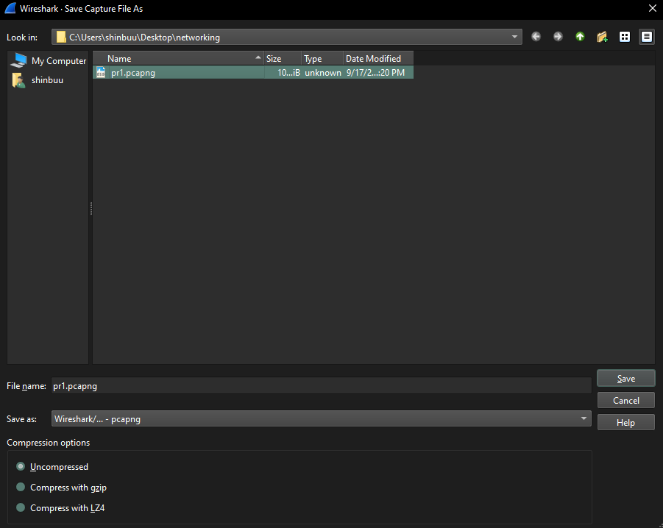
- Traffic Capture
Based on the data from the "Protocol Hierarchy Statistics", the percentage distribution of the main protocols in the traffic was determined:
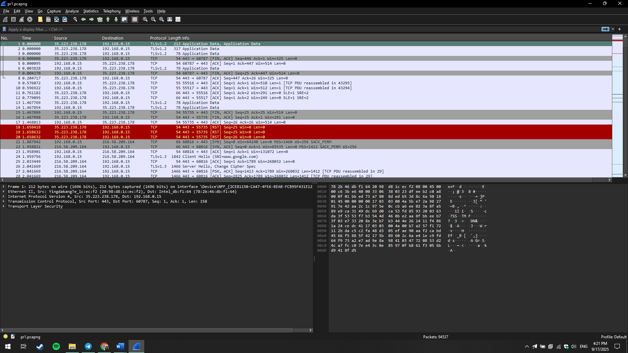
- Protocol Analysis
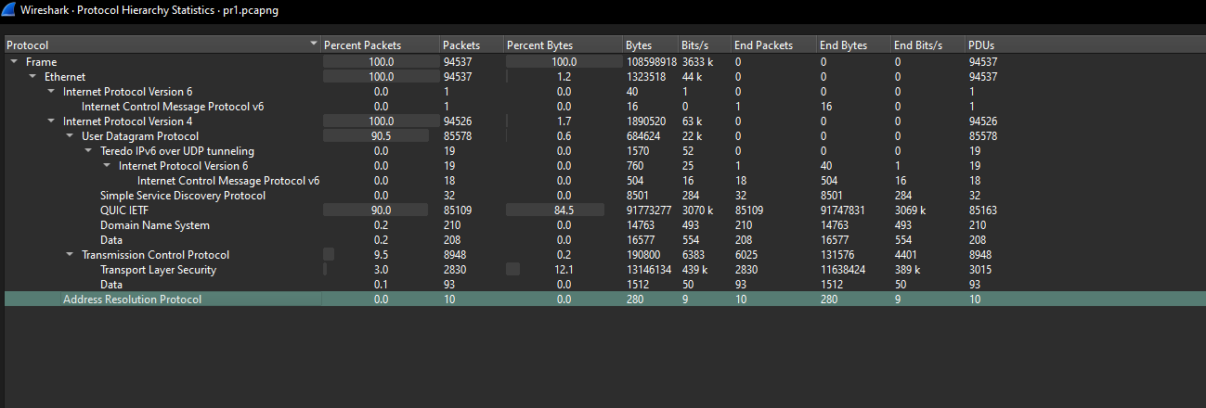
QUIC IETF: A modern protocol used to accelerate web traffic and provide a faster and more reliable connection. Its dominant position (90%) indicates that most of the traffic comes from modern web applications (e.g., Google Chrome).
TCP (Transmission Control Protocol): One of the fundamental Internet protocols that provides reliable and ordered data delivery. It is used for most standard web connections.
TLSv1.3 (Transport Layer Security): A security protocol that encrypts data transmitted over the network. It is used to protect the confidentiality of information, such as when browsing HTTPS sites.
DNS (Domain Name System): A protocol that translates human-readable domain names (e.g., google.com) into machine-readable IP addresses, allowing computers to locate each other on the network.
ARP (Address Resolution Protocol): A protocol used in a local network to map IP addresses to the MAC addresses of devices.
- Anomaly / Attack Detection
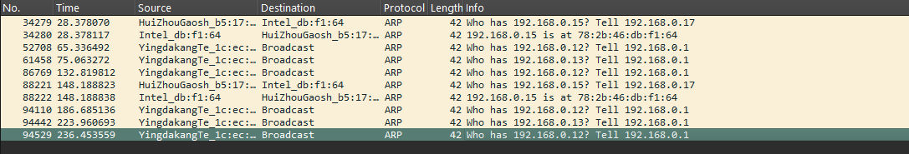
The screenshot with ARP traffic shows repeated requests from the same source (YingdakangTe_1c:ec: Broadcast) to different IP addresses (192.168.0.12, 192.168.0.13, etc.). This behavior is suspicious and could be a sign of:
- Network Scanning: An attacker's attempt to gather information about the network topology.
- ARP Spoofing: Preparation for a "Man-in-the-Middle" attack, where the attacker tries to associate their MAC address with a gateway's IP address to intercept traffic.
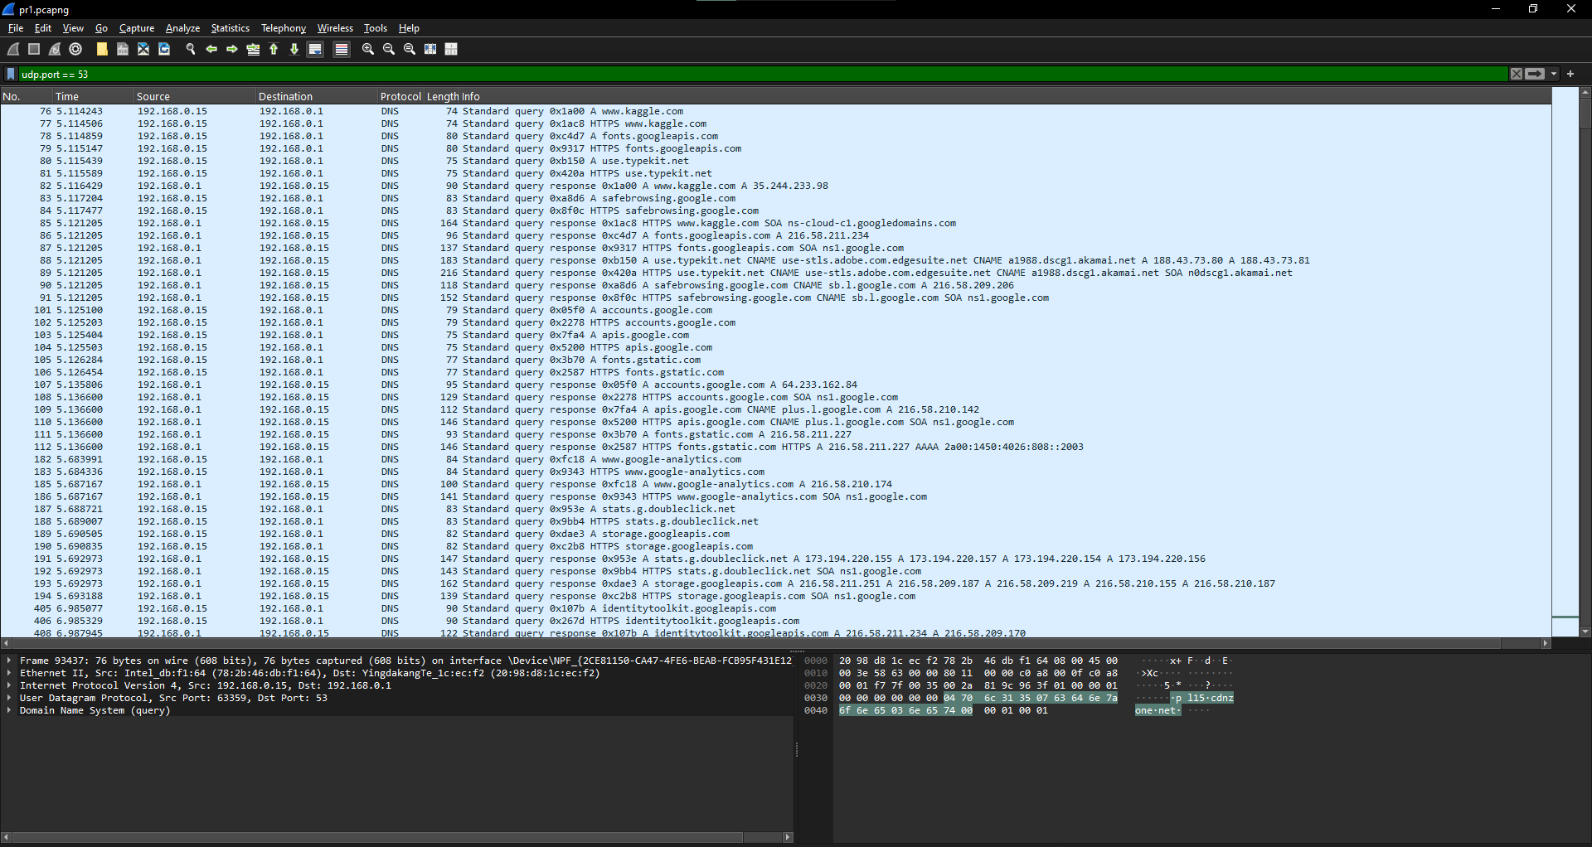
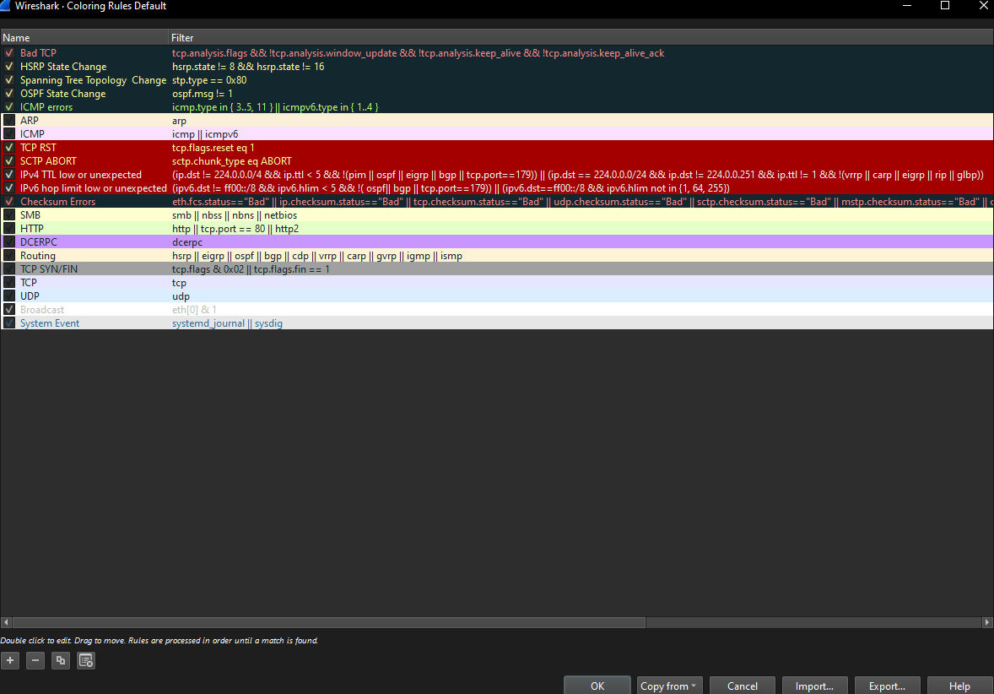
The provided screenshot shows a list of packets with a focus on TCP anomalies highlighted by Wireshark's coloring rules. This indicates significant issues with the network connection's reliability.
Key Observations:
- TCP Retransmissions: Packets are being resent, which happens when the sender doesn't receive an acknowledgment for a previously sent packet within a set time. This is a clear sign of packet loss.
- Duplicate Acknowledgements (Dup ACK): The presence of multiple [TCP Dup ACK] flags means the receiver is repeatedly acknowledging the last successfully received in-order packet. This further confirms that one or more packets were lost or arrived out of order.
- Out-of-Order Packets: The [TCP Out-of-Order] flag indicates that a packet was received in an unexpected sequence. This can be a symptom of network congestion, unstable routing, or packet loss.
Wireshark Coloring Rules:
The coloring rules in Wireshark automatically highlight these issues, providing a visual cue for network analysis.
- Red: Marks "Bad TCP" traffic, including retransmissions, connection resets (RST), and other errors. This color indicates that something went wrong with the TCP session.
- Black: Used for packets with bad checksums, which means the data was corrupted during transmission.

b) TCP Connection Issues
The traffic contained packets with [TCP Dup ACK] (Duplicate Acknowledgement) and [TCP Out-Of-Order] (Out-of-Order) flags. These packets indicate problems with connection reliability, such as packet loss or out-of-order reception.
Additionally, a packet with [TCP Retransmission] was recorded, which confirms delivery issues: the sender retransmitted the packet because it did not receive an acknowledgment of its delivery. This could be caused by network congestion or high latency.
The network traffic analysis revealed both normal behavior and several anomalies that require attention. The presence of repeated ARP requests and TCP connection issues (retransmissions and Dup ACK) indicates potential vulnerabilities.
To improve network security, it is recommended to:
- Use Intrusion Detection Systems (IDS) to automatically monitor for suspicious traffic, such as mass ARP requests.
- Configure static ARP entries for critical devices to prevent ARP spoofing.
- Regularly update network device firmware and software to fix vulnerabilities.

Topic 2: Attack Modeling — STRIDE and Kill Chain model construction; justification of attack scenario and proposed countermeasures.
Threat Modeling (Homomorphic Encryption + MFA)
Purpose: build DFDs, apply STRIDE, create attack scenarios with Kill Chain / MITRE ATT&CK, perform risk assessment, and propose mitigations for a cloud-based MFA system that uses homomorphic encryption to protect OTPs/biometric templates when processed in the cloud.
1. System scope and assumptions
High-level description.
A cloud-hosted MFA service that offers OTP/TOTP generation and verification. Sensitive credential data are stored and processed using partial homomorphic encryption (PHE) so the cloud can perform comparisons/verification without access to plaintext. Clients (web/mobile apps) integrate SDK to call the MFA API. Identity Provider (IdP) / Authentication Server integrates the MFA service via REST/HTTPS.
Primary components (boundaries):
- User Device (Browser/Mobile app) — collects credentials, second factor (TOTP app, SMS fallback), and performs local crypto (client-side key ops). Trusted.
- Authentication Server (IdP) — corporate identity provider (connects to MFA API). Trusted.
- MFA Cloud Service — hosts HE-enabled verification microservice, stores encrypted templates/OTP seeds. Partially trusted (zero-knowledge intent).
- Key Management Service (KMS) — may hold keys or key shares; could be HSM or client-side secrets. Trusted if on-prem; otherwise semi-trusted.
- Admin Console — admin UI to manage policies and enrollments.
- Attackers/Network — external internet, potential insider.
Trusted / Untrusted zones:
- Trusted: User device local secure enclave, on-prem KMS, IdP.
- Semi-trusted: MFA Cloud service (processes encrypted data), Admin console (authenticated admins).
- Untrusted: Public internet, attacker nodes.
2. Data Flow Diagrams
Level 0 (Context)
[User Device] --(Authenticate request via HTTPS)--> [Authentication Server/IdP]
[Authentication Server] --(MFA request: encrypted token + metadata)--> [MFA Cloud Service]
[MFA Cloud Service] --(response: encrypted decision)--> [Authentication Server]
[MFA Cloud Service] --(store/retrieve)--> [Encrypted Template DB]
[MFA Cloud Service] <--> [KMS / HSM] (key operations / key shares)
[Admin Console] --(manage policies)--> [MFA Cloud Service]
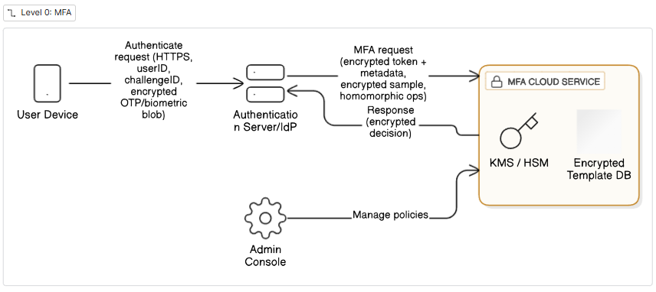
This diagram shows the general outline of a multifactor authentication system using homomorphic encryption.
The user device sends an authentication request to the identity server. The server transmits encrypted data to an external cloud-based MFA service. This service works with encrypted templates and never sees the original data in clear text. Within the cloud, the data is verified, and the decision to allow the user through or reject the request is returned to the identity server.
We also have an admin console that allows administrators to manage authentication policies and a key management service (KMS or HSM), which is used for cryptographic operations.
Labelled flows:
* Auth request: HTTPS POST /auth — contains user id, challenge id, encrypted OTP/biometric blob (confidential).
* MFA API call: HTTPS POST /mfa/verify — encrypted sample, homomorphic ops request (confidential).
* Template store: EncryptedTemplate (confidential, high sensitivity).
Level 1 (Detailed for MFA Cloud Service)
[Authentication Server] --(HTTPS: VerifyRequest {userID, challengeID, enc_sample})--> (1) API Gateway
(1) API Gateway --> (2) Verification Service (HE engine)
(2) Verification Service --(requests)--> (3) Encrypted Template Store
(2) Verification Service --(key ops)--> (4) KMS/HSM
(2) Verification Service --> (5) Decision Service (policy engine)
(5) Decision Service --> (1) API Gateway --> [Authentication Server]
(6) Admin Console --(HTTPS)--> (1) API Gateway --> (7) Admin DB
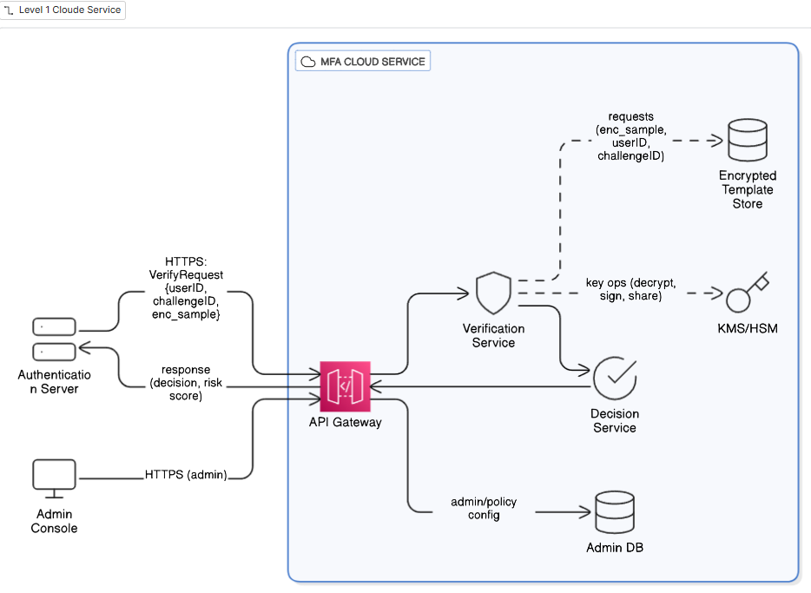
The following diagram shows how the cloud MFA service is structured internally.
All external requests first pass through the API Gateway—this is the entry point that routes requests further. Then, the Verification Service, or homomorphic encryption engine, verifies the encrypted data. To perform the verification, it accesses a database of encrypted templates and interacts with the KMS or HSM to perform cryptographic operations.
The verification results are passed to the Decision Service, where policies are considered and a final decision is made: successful authentication or failure. This result is returned to the identity server via the API Gateway.
At the same time, administrators can manage security policies through the admin console. These settings are stored in a separate database for administrators and also affect the operation of the Decision Service.
Data types & sensitivity:
* enc_sample (encrypted biometric vector or encrypted OTP seed) — Confidential (High)
* userID, challengeID — Internal
* decision (allow/deny, risk score) — Internal
* audit logs — Internal/Confidential depending on content
Protocols: HTTPS (TLS 1.3) between external components; mTLS recommended between internal services; KMS uses secure key protocol (PKCS#11 or KMS API over TLS).
3. STRIDE analysis (selected/high-priority items)
DFD Element | STRIDE | Threat Description | Attack Vector | Likelihood | Impact
API Gateway / HTTPS Flow | Spoofing | Attacker spoofs Auth Server or device to call MFA API, bypassing rate limits or triggering false enrolls | Compromised API keys, stolen client credentials, weak mutual auth | M | H
Encrypted Template Store | Tampering | Attacker modifies encrypted templates to cause false accepts or denial | Compromise DB credentials, exploit injection in admin API | M | H
Encrypted Template Store | Information disclosure | Leakage of encrypted templates allowing offline cryptanalysis / inference | Backup misconfiguration, improper access controls, insider | L | H (depends on HE strength)
Verification Service (HE engine) | Elevation of Privilege | Vulnerability in HE engine allows remote code execution leading to key access | Unpatched library, deserialization bug | M | H
KMS/HSM interface | Repudiation | Lack of secure logging allows malicious admin to deny changes to keys | Poor logging/auditing | M | M
API Gateway | DoS | Flooding MFA API causing authentication outages | Botnet DDoS or brute force from many clients | H | M
Decision Service (Policy engine) | Information disclosure | Excessive logging includes sensitive metadata (partially reconstructable features) | Verbose logs stored in plain text | M | M
User Device (SMS fallback) | Information disclosure / Spoofing | SIM swap or interception of SMS OTP | Social engineering, telecommunication compromise | M | H

Notes: Likelihood/Impact are qualitative: H/M/L. The confidentiality of encrypted templates depends on whether the homomorphic scheme + parameters resist ciphertext-only attacks; storing ciphertexts doesn't equal safe forever — side-channel and metadata attacks remain.
4. Attack scenarios:
Scenario A — Remote compromise that leads to template tampering and account takeover
Selected threat(s): Tampering (templates), Spoofing (API), Elevation (HE engine exploit)
Kill Chain mapping (Lockheed Martin):
1. Recon — attacker enumerates MFA API endpoints, finds admin panel login and outdated library versions.
2. Weaponization — craft exploit payload for a known deserialization vulnerability in HE engine or verification microservice.
3. Delivery — POST exploit via authenticated-but-stolen API key or via admin console upload endpoint (CSRF/weak auth).
4. Exploitation — RCE in Verification Service exploiting deserialization leads to code execution.
5. Installation — attacker implants a backdoor or modifies verification logic.
6. Command & Control — attacker reaches out to C2 to exfiltrate logs or coordinate.
7. Actions on Objectives — attacker tampers encrypted templates to cause false accepts or creates a secret backdoor that bypasses HE checks.
MITRE ATT&CK mapping (examples):
* Reconnaissance: T1595 Active Scanning.
* Initial Access: T1190 Exploit Public-Facing Application (or T1078 Valid Accounts if API key stolen).
* Execution: T1059 Command and Scripting Interpreter.
* Persistence: T1505 Server Software Component.
* Privilege Escalation: T1068 Exploitation for Privilege Escalation.
* Collection: T1119 Automated Collection (logs, DB dumps).
* Exfiltration: T1041 Exfiltration Over C2 Channel.
IoCs & detection opportunities:
Sudden injection of new processes in verification service; anomalous outbound connections; modification timestamps of encrypted templates; unexpected admin API calls from unusual IPs; new privileged user creation.
Mitigation highlights:
Enforce mTLS and short-lived service credentials; WAF to block exploit attempts; runtime integrity checking of binaries; immutable infrastructure and ephemeral containers to prevent persistent tampering; signed templates and HMACs over ciphertexts to detect tamper; automated file integrity monitoring; robust audit logging to detect changes.
Risk (qualitative): Likelihood M, Impact H → High risk → prioritize.
Scenario B — Attacker performs SIM-swap + Man-in-the-Middle to bypass fallback OTP
Selected threat(s): Spoofing, Information disclosure
Kill Chain steps:
1. Recon — identify target users with high-value accounts (social media or admin) via OSINT.
2. Weaponization — prepare social engineering scripts and acquire phone carrier account details.
3. Delivery — social engineer contacts telco and performs SIM swap or tricks support.
4. Exploitation — attacker receives OTP SMS and uses it to authenticate.
5. Installation — (optional) attacker registers device for persistent access.
6. C2 — not needed for simple account takeover.
7. Objective — access account, perform privilege actions or data exfiltration.
MITRE mapping:
* Initial Access: T1078 Valid Accounts (using stolen OTP).
* Credential Access: T1531 Account Access Removal (SIM swap enabling access).

IoCs & detection:
Sudden OTP requests from new IPs; multiple SIM-change requests for account; telco notifications of SIM change; failed MFA attempts followed by successful login from new location.
Mitigations:
Avoid SMS fallback as the sole second factor; use push-based or app-based TOTP with device attestation; detect SIM-change via telco APIs and block risky operations for 24–48h; implement number-port-out protection and customer notification.
Risk: Likelihood M, Impact H → High.
5. Risk assessment matrix and prioritized controls
Simple matrix:
* High risk: Scenario A (template tampering via exploitation), Scenario B (SIM swap)
* Medium risk: Denial of Service, insider access to logs
* Low risk: ciphertext-only leakage (assuming strong HE parameters)
Technical controls (with short justification and validation):

Risk Matrix
Scenario | Likelihood | Impact | Risk Level (L×I)
A — Remote compromise via HE engine exploit + template tampering | M | H | High
B — SIM-swap + SMS OTP interception | M | H | High

Mitigation Measures, Scenario A — Remote compromise / template tampering
Control Type | Measure | Expected Risk Reduction | Implementation Effort | Validation Metrics
Technical | mTLS + short-lived service credentials between API Gateway, Verification Service, and KMS | Reduces spoofing, prevents attacker reuse of stolen API keys | Medium — requires certificate management & rotation infra | % of internal calls using mTLS; TLS cert rotation logs
Technical | WAF + RASP (runtime app self-protection) to block exploit payloads and detect deserialization attempts | Mitigates exploitation attempts, early detection | Medium–High — integration effort, tuning needed | WAF log of blocked exploit attempts; false positive rate
Technical | Signed/HMAC-validated encrypted templates | Detects tampering before use, prevents silent modification | Medium — cryptographic changes to storage pipeline | % of templates validated before use; tamper alerts triggered
Technical | Immutable infrastructure & ephemeral containers | Prevents persistence after RCE, limits attacker foothold | High — infra/DevOps change | Container lifetime median < 24h; drift detection events
Organizational | Patch & dependency management policy for HE engine | Prevents exploitation of known vulnerabilities | Medium — requires CI/CD pipeline integration | Mean Time To Patch (MTTP) < 14 days; patch compliance rate
Organizational | Security logging & monitoring with anomaly detection | Early detection of abnormal admin API use or template changes | Medium–High — SIEM integration | % of critical events monitored; detection-to-response time

Scenario B — SIM-swap + SMS OTP interception
Control Type | Measure | Expected Risk Reduction | Implementation Effort | Validation Metrics
Technical | Deprecate or restrict SMS fallback; prefer TOTP/push MFA with device binding | Removes SIM-swap attack vector | Medium — requires user adoption + client app changes | % of users migrated to TOTP/push; SMS usage rate
Technical | SIM-change detection (via telco APIs or third-party services) | Detects suspicious account recovery attempts | Medium — depends on telco integration | % of blocked transactions after SIM change; detection coverage
Technical | Risk-based authentication (RBA): extra verification for logins from new devices/locations after SIM swap | Raises bar for attacker after SIM takeover | Medium–High — requires policy engine updates | % of risky logins flagged; false positive rate
Organizational | User awareness training on SIM-swap/social engineering | Reduces success rate of attacker social engineering | Low — training sessions, awareness material | User quiz results; reduction in SIM swap incidents
Organizational | Telco contract with port-out protection | Hardens against insider fraud and unauthorized number transfers | Medium — negotiation with provider | SLA guarantees; # of unauthorized port-out attempts prevented
Organizational | Policy: high-value accounts cannot use SMS fallback | Limits exposure of privileged/admin accounts | Low — enforce via admin console | % of privileged accounts without SMS enabled

Topic 3: Cryptographic Protocols Exploration. Exploring Cryptographic Protocols: SSL/TLS setup with OpenSSL and TLS Handshake Analysis

Objectives
In this work we aimed to gain practical experience with the TLS protocol. The tasks included:
- generating a key and certificate using OpenSSL,
- running a TLS server and client,
- analyzing the handshake process in Wireshark,
- experimenting with cipher suite restrictions, TLS versions, and invalid certificates,
- making conclusions about secure communication.

Preparation
- We used Debian Linux, where OpenSSL is already built-in.
- Installed Wireshark for packet analysis.
- OpenSSL already in Debian

Key and Certificate Generation
- First, a private RSA key (2048 bits) was generated.
- Then, a self-signed X.509 certificate valid for 365 days was created.
This certificate was required for the server, so the client could verify its authenticity.
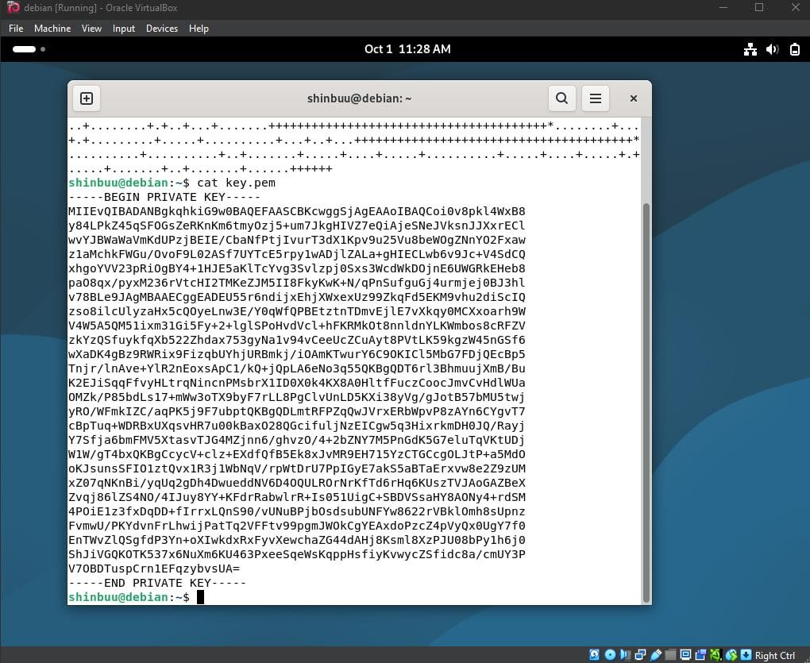

Server and Client Setup
- The TLS server was launched on port 4433 using the generated key and certificate.
- The client (openssl s_client) connected to the server.
- The client output displayed the certificate, the chosen cipher suite, and the TLS version (TLS 1.3).
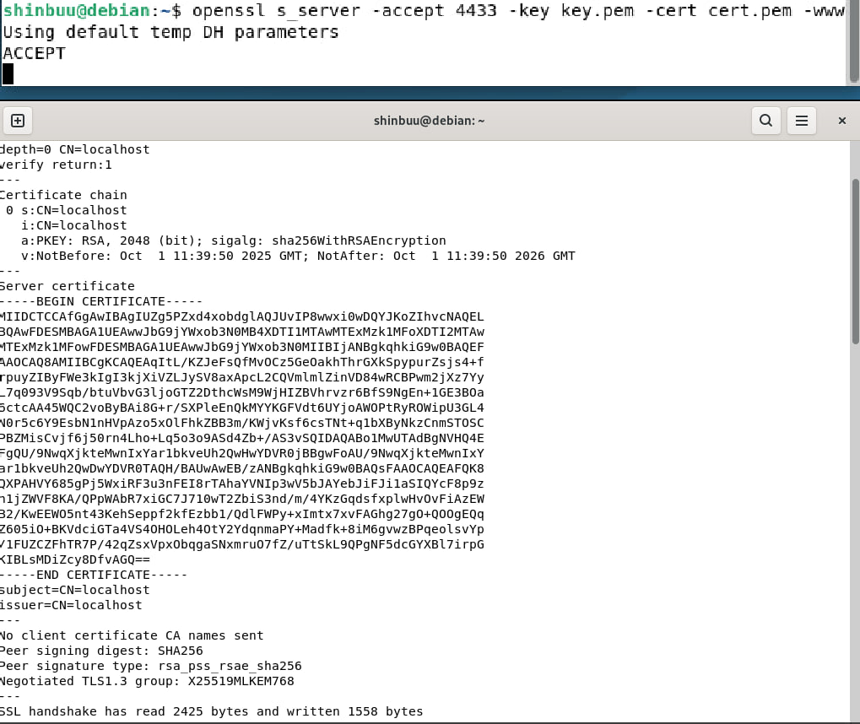

Handshake Analysis in Wireshark
- In Wireshark, the lo (loopback) interface was selected because the connection was made via 127.0.0.1.
- Packets were filtered by port 4433.
- The following sequence was observed:
  - ClientHello – client offered a list of supported cipher suites.
  - ServerHello – server selected one cipher suite.
  - Certificate – server sent its certificate.
  - Finished – handshake completion.

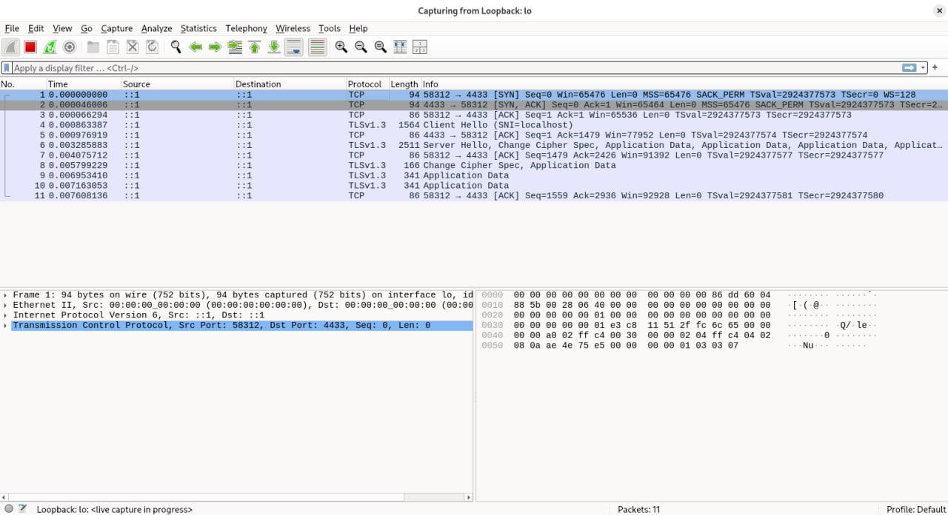
In TLS 1_3 Certificate and Finished are ecnrypted compared to TLS 1_2
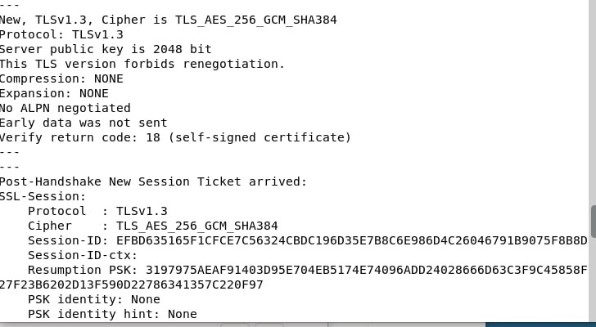

Experiments

Restricting Cipher Suites
The server was started with a single cipher suite (ECDHE-RSA-AES256-GCM-SHA384).
As a result, the server always chose this suite. This demonstrated how the server controls algorithm selection.

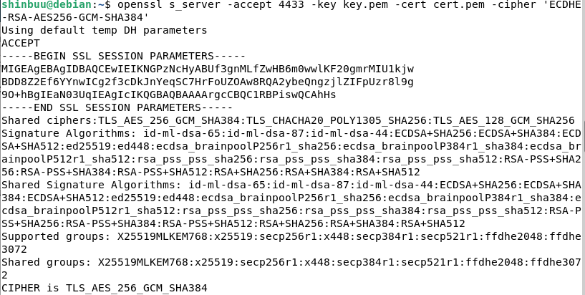

Comparing TLS 1.2 and TLS 1.3
    - With TLS 1.2, the client and server exchanged more handshake messages.
    - TLS 1.3 was faster, requiring fewer steps to establish a connection and using more modern algorithms.
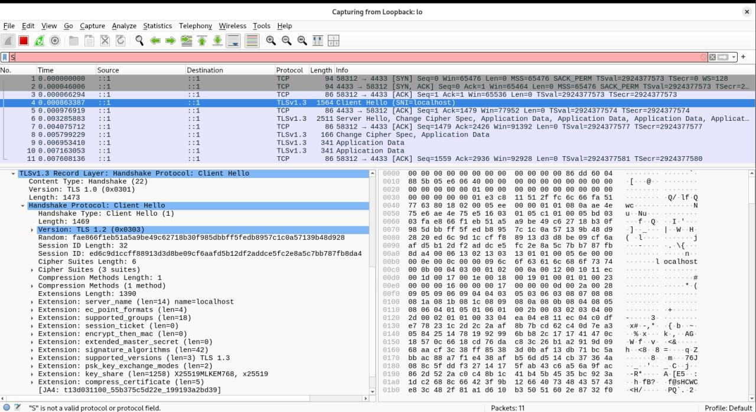

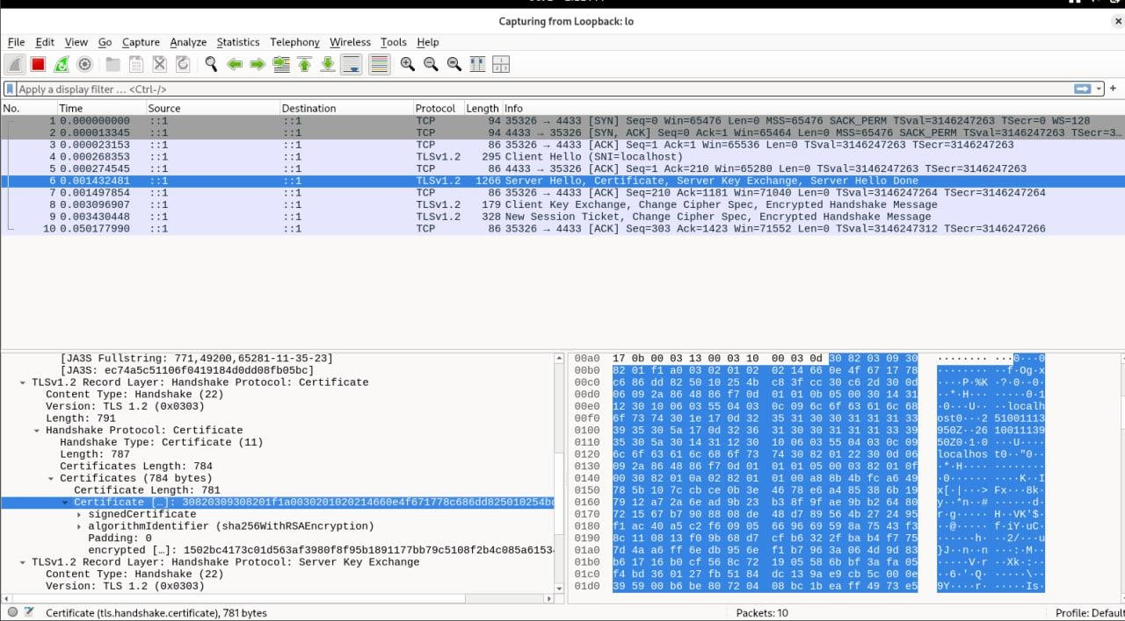
As we can see there Certificate and algorithm that was used in TLS 1_2

Invalid and Expired Certificates
A certificate with past validity dates was generated (using faketime). The client returned the error:
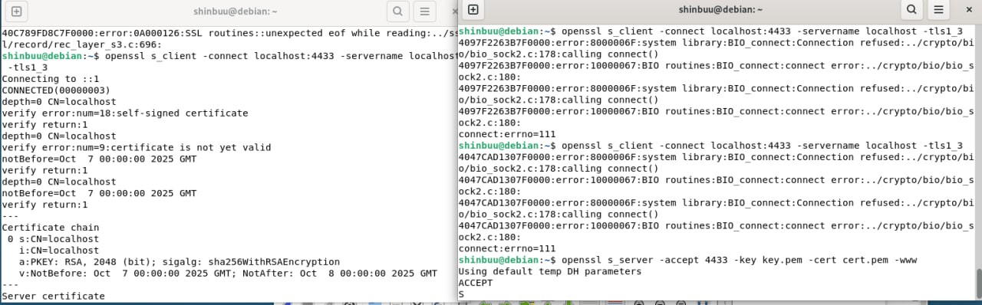
These experiments confirmed that certificate validation works as a protection against fake or outdated credentials.

Results and Conclusions
- Key and certificate generation was successful.
- TLS server and client established a secure connection.
- Wireshark confirmed the handshake process and algorithm selection.
- TLS 1.3 showed better performance and security compared to TLS 1.2.
- Invalid certificates resulted in verification errors, highlighting the importance of proper configuration.

Final Conclusion
We gained practical knowledge of TLS, including how certificates, algorithms, and protocol versions operate.
Main takeaways:
- Always use up-to-date TLS versions (TLS 1.3).
- Certificates must be valid (with correct CN and expiration dates).
- Weak or outdated cipher suites should not be used.
- Tools like OpenSSL and Wireshark are valuable for understanding the inner workings of cryptographic protocols.

Topic 4: Authentication and Authorization Implementation (OAuth2 / Keycloak deployment, IAM principles)

Keycloak Resource Server Integration Lab Report
The purpose of this lab is to integrate Keycloak as an Identity and Access Management (IAM) solution with a simple resource server. The lab demonstrates authentication and authorization using Keycloak-issued tokens, role-based access control, and token refresh functionality.

Environment Setup
Keycloak was installed locally and a new realm named 'lab-realm' was created. Two users were configured:
  - user1 (assigned ROLE_USER)
  - admin1 (assigned ROLE_ADMIN)
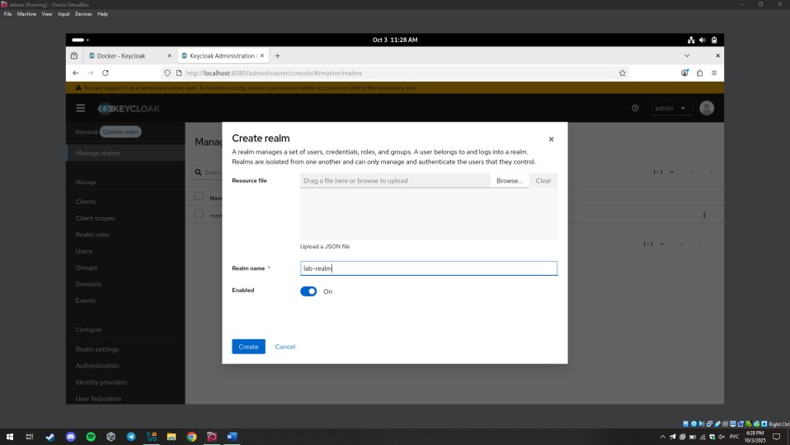

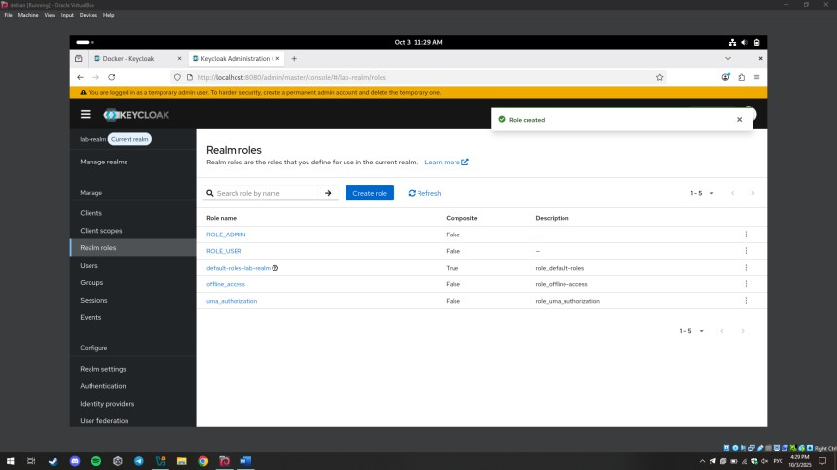

A demo client ('demo-client') was created with the following settings:
    - Standard flow enabled
    - Direct access grants enabled
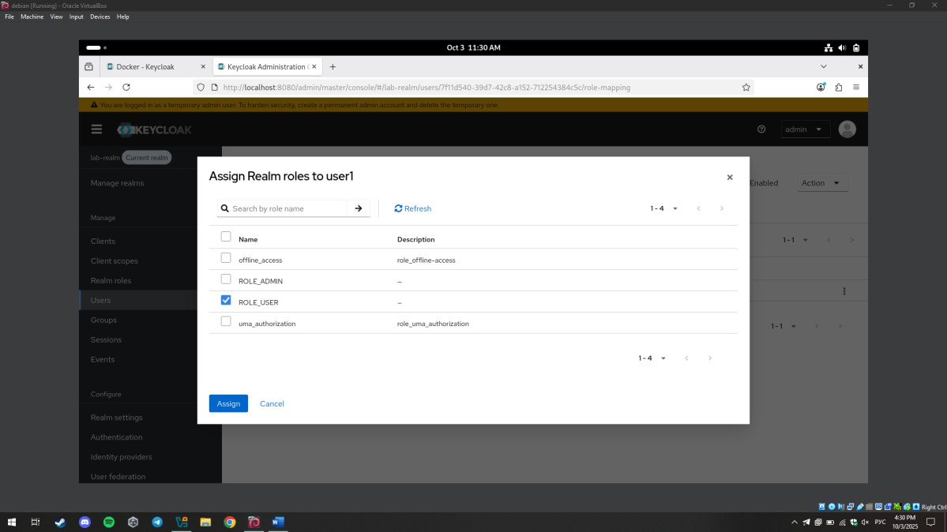
  - Client authentication disabled
Screenshot:

Resource Server Implementation
A simple Python Flask application was developed with two endpoints:
  - /user → accessible to ROLE_USER and ROLE_ADMIN
  - /admin → accessible only to ROLE_ADMIN

JWT validation was implemented using the Keycloak public key. Role checks were added to enforce access restrictions.
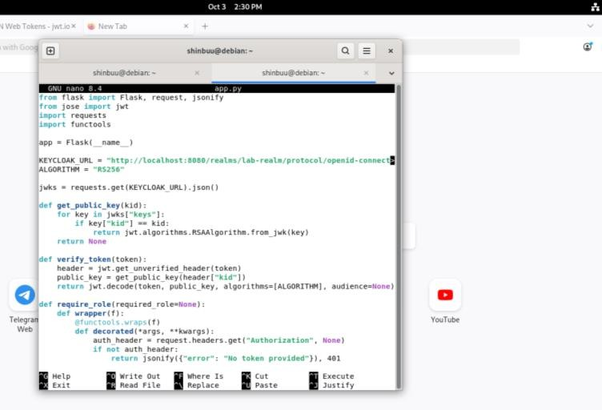
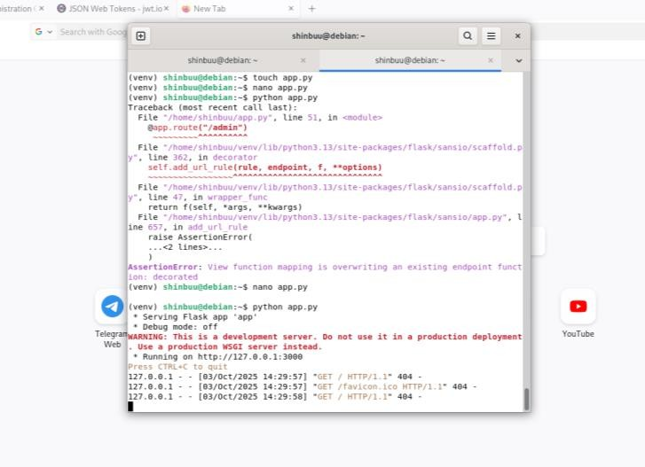

Testing Access with Tokens
Access tokens were obtained via Direct Access Grants using cURL commands. The following tests were performed:
  - Accessing /user with user1 → SUCCESS
  - Accessing /admin with user1 → FORBIDDEN
  - Accessing /user with admin1 → SUCCESS
  - Accessing /admin with admin1 → SUCCESS
  - Accessing without token → UNAUTHORIZED
  - Accessing with expired token → INVALID TOKEN

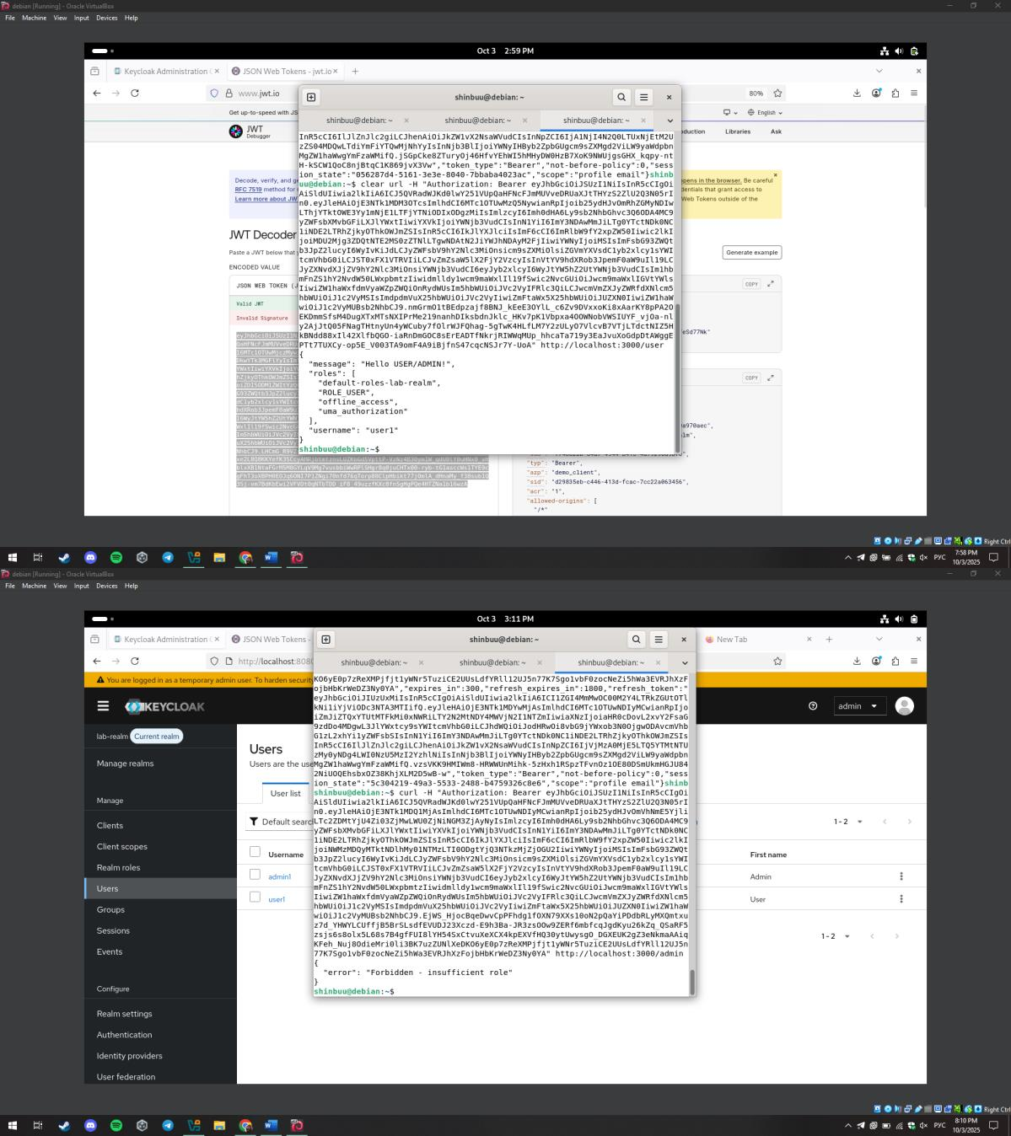

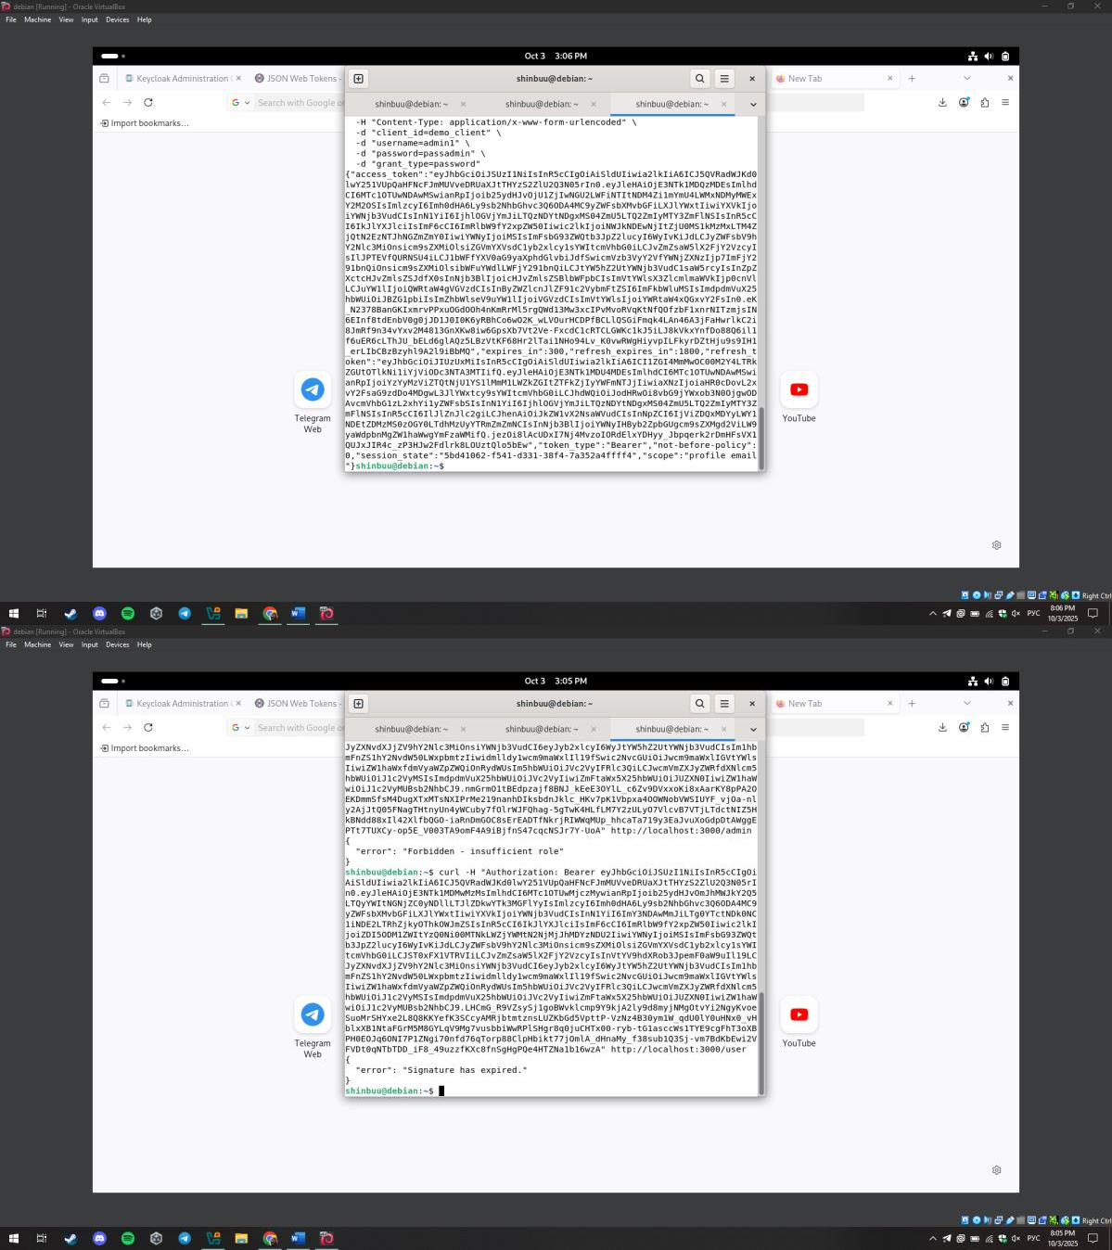

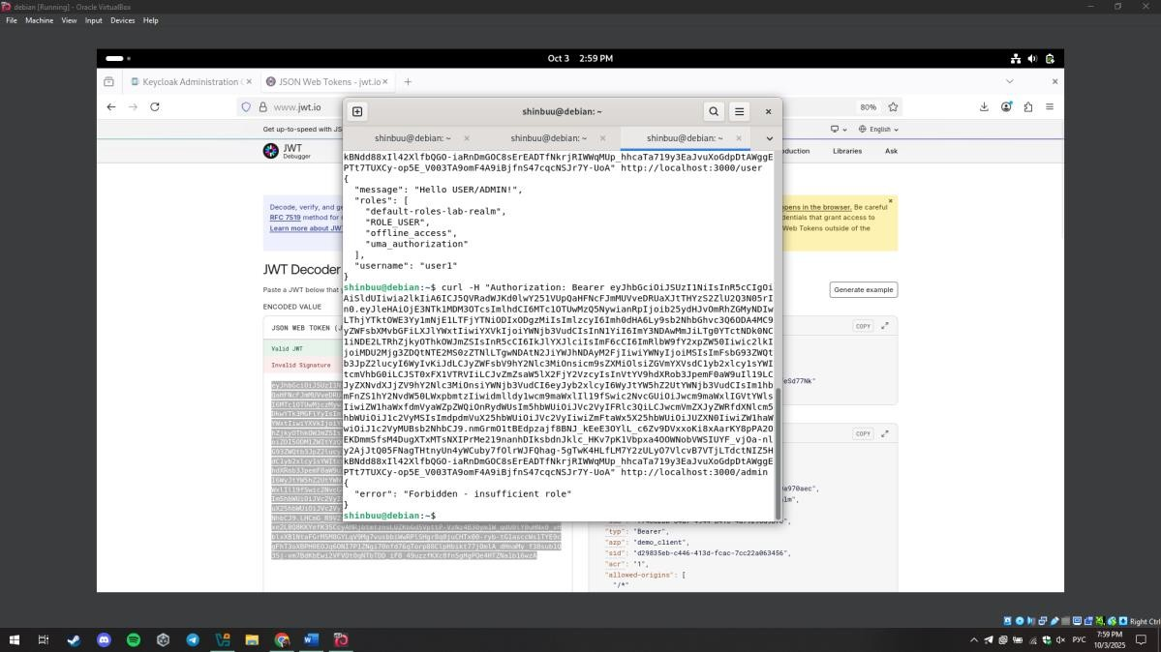

Role Modification
User roles were modified in Keycloak. For example, ROLE_ADMIN was removed from admin1. After obtaining a new token, the user could no longer access the /admin endpoint. This confirmed that Keycloak role assignments directly affect authorization.
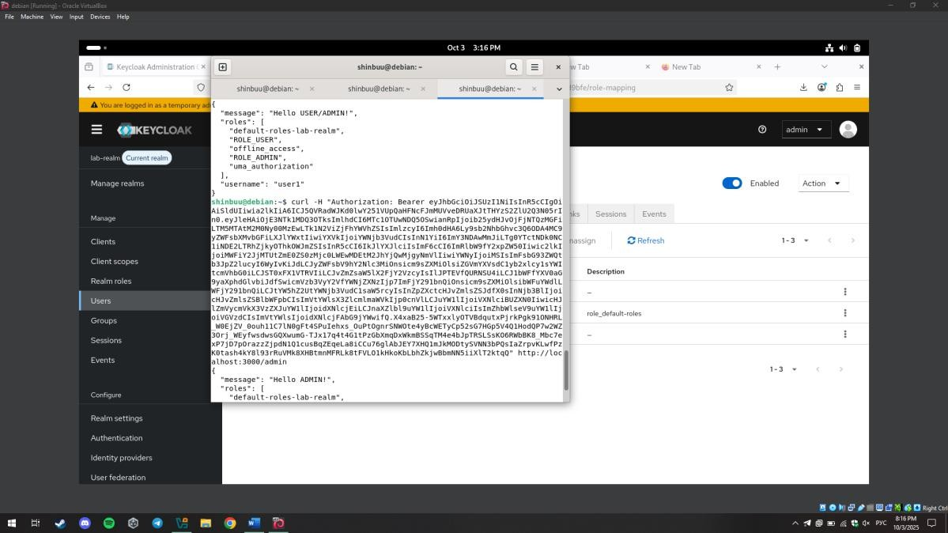
Screenshot:

Comparison of Flows
Two authentication flows were compared:
  - Password Grant (Direct Access Grants): Simple to test with cURL, but less secure because it requires the client to handle user credentials directly.
  - Authorization Code Flow (Standard Flow): More secure, since credentials are only entered at Keycloak's login page and the client receives only tokens.
The lab primarily used Direct Access Grants, but Standard Flow is recommended for production.

Conclusion
The lab successfully demonstrated Keycloak integration with a resource server, role-based access control, and token management. Key results include:
  - Verified access control based on roles
  - Demonstrated role modification impact
  - Tested refresh token usage
  - Compared Direct Access vs Standard Flow

Topic 5: Deployment and Testing of Intrusion Detection Systems (Suricata)

Objectives
• Understand IDS/IPS principles.
• Install and configure Suricata on Debian.
• Generate normal and malicious traffic, analyze logs, and create custom rules.

Environment
OS: Debian (testing environment)
Suricata version: 7.0.10
Tools used: curl, wget, ping, nmap, hping3, python3 (simple http.server), jq
Commands:
sudo apt update && sudo apt upgrade -y
sudo apt install suricata -y
sudo suricata -T -c /etc/suricata/suricata.yaml
sudo suricata -c /etc/suricata/suricata.yaml -i lo -v
sudo suricata-update
sudo systemctl restart suricata
ping -c 3 127.0.0.1
curl -i -X TRACE http://127.0.0.1:8080
curl -I -H "X-Long: A... (long header)" http://127.0.0.1:8080
nmap -sS -Pn 127.0.0.1
sudo hping3 --icmp -c 200 -i u2000 127.0.0.1

1. IDS Installation
Commands run:
sudo apt update && sudo apt upgrade -y
sudo apt install suricata -y
suricata -V
sudo suricata -T -c /etc/suricata/suricata.yaml

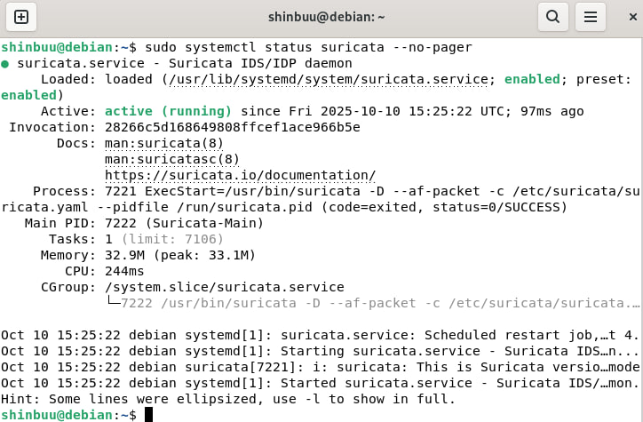

2. Basic Configuration
Configured Suricata to monitor the loopback interface (lo) and enabled logging outputs (fast.log and eve.json).
Key configuration snippets:
af-packet:
- interface: eth3
cluster-id: 99
cluster-type: cluster_flow
defrag: yes
outputs:
- fast:
enabled: yes
filename: fast.log
- eve-log:
enabled: yes
filetype: regular
filename: eve.json
types:
- alert
- dns
- http

3. Normal Traffic Testing
Procedure:
1. Start Suricata on loopback: sudo suricata -c /etc/suricata/suricata.yaml -i lo -v
2. Generate benign traffic:
- ping -c 3 127.0.0.1
- curl http://example.com
- wget http://example.com -O /tmp/test.html
Observed behavior: Normal traffic produced entries in eve.json (HTTP, DNS, flow events) and typically did not trigger alerts in fast.log.
{"event_type":"http","src_ip":"127.0.0.1","dest_ip":"93.184.216.34","http":{"hostname":"example.com","url":"/"}}
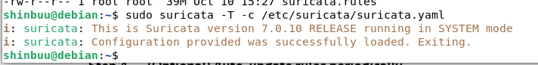

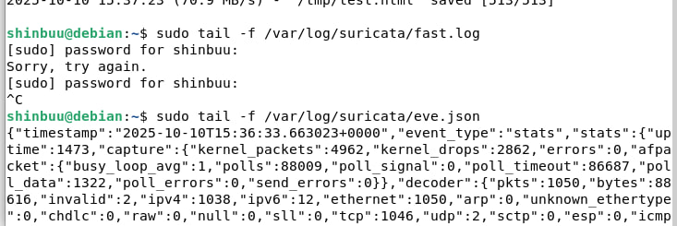

4. Attack Simulation
Performed controlled attacks on loopback (127.0.0.1):
- Port scanning with nmap (local): nmap -sS -Pn 127.0.0.1
- HTTP requests with unusual headers and methods
- Controlled ICMP rate using hping3 or nping
- Multiple rapid HTTP GETs to simulate hammering

5. IDS Log Analysis
Log files analyzed: /var/log/suricata/eve.json and /var/log/suricata/fast.log
Fields inspected in alerts: event_type, timestamp, src_ip, dest_ip, alert.signature, alert.signature_id (sid), category, severity.
Sample alert (custom rule example):
{
"event_type": "alert",
"timestamp": "2025-10-10T12:34:56.789012",
"src_ip": "127.0.0.1",
"dest_ip": "127.0.0.1",
"alert": {
"signature": "HTTP TRACE Detected",
"signature_id": 100002
}
}

6. Custom Rule Creation
Custom rules added to local.rules (path used during testing: /var/lib/suricata/rules/local.rules):
1) ICMP detection rule:
alert icmp any any -> any any (msg:"ICMP Detected"; sid:100001; rev:1;)
2) HTTP TRACE detection rule:
alert tcp any any -> any 8080 (msg:"HTTP TRACE Detected"; flow:to_server,established; pcre:"/^TRACE\s/"; sid:100002; rev:1;)
3) Long header detection rule:
alert tcp any any -> any 8080 (msg:"HTTP Long Header X-Long"; flow:to_server,established; pcre:"/X-Long:\s*A{500,}/smi"; sid:100003; rev:1;)
Testing steps: restart Suricata or run in foreground on lo, then generate matching traffic (ping, curl TRACE, curl with long X-Long header).

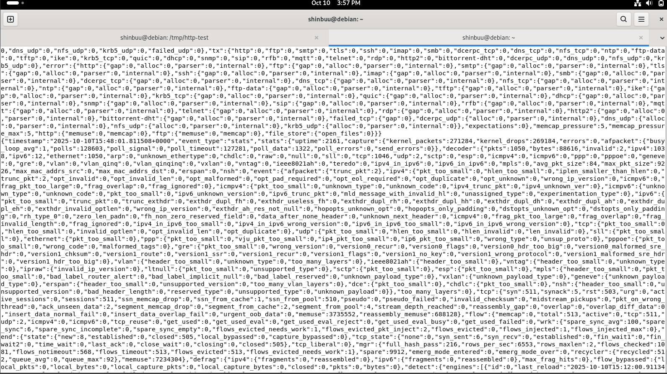]

Comparison between Normal and Attack Traffic
Normal traffic produced informational http/dns/flow events without alerts. Attack simulations triggered alert events with associated SIDs and signatures. Custom rules fired for the TRACE method and long header cases during testing.
Limitations observed:
- Large headers may be fragmented across multiple packets; PCRE matching could fail if pattern spans packets.
- Running in AF_PACKET mode requires root; performance considerations apply for high-rate tests.
- Potential for false positives; tuning required in production.

Conclusions
Suricata successfully installed and configured on Debian, monitored the loopback interface, and logged both normal and malicious activity. Custom rules were created and validated. The experiment demonstrates Suricata's flexibility and highlights the need for careful tuning and testing in a production environment.

Topic 6: Routing Security: BGP / OSPF — simulating a BGP route hijack in Packet Tracer

Open Packet Tracer, assemble the topology, enter the commands listed for each router, run checks with show ip bgp and traceroute, then simulate the hijack and apply the filter.
Topology — build this in Packet Tracer

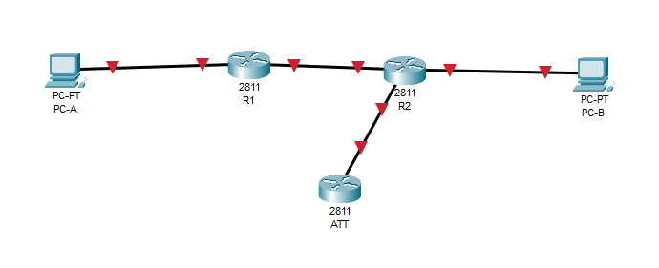
Addresses and interfaces

R1
Fa0/0: 10.0.12.1/24 (link to R2 Fa0/0)
Fa0/1: 192.168.10.1/24 (PC-A gateway)
R2
Fa0/0: 10.0.12.2/24 (link to R1)
Fa0/1: 192.168.20.1/24 (PC-B gateway)
Fa1/0: 10.0.13.1/24 (link to ATT)
ATT (Attacker)
Fa0/0: 10.0.13.2/24 (link to R2 Fa0/1)
PC-A: 192.168.10.10/24, GW = 192.168.10.1
PC-B: 192.168.20.10/24, GW = 192.168.20.1

(Cisco 2811 routers in Packet Tracer; two Desktop PCs.)

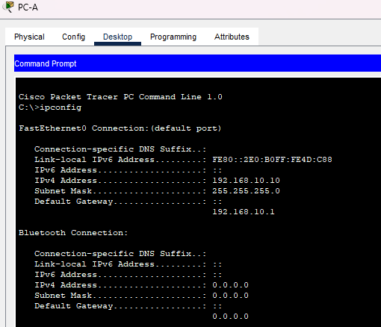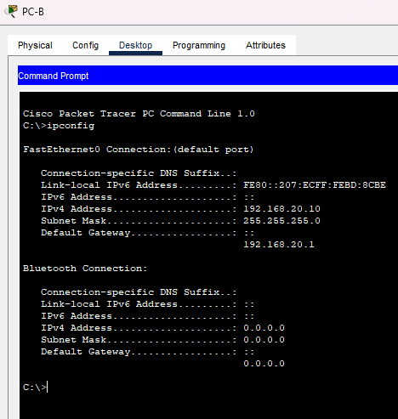
Preparation
- In Packet Tracer add devices: R1, R2, ATT (routers), PC-A and PC-B (PCs).
- Connect devices with straight-through cables (Fa ↔ Fa).
- On PCs set IP and gateway (Desktop → IP Configuration).
- Open CLI on each router.

Configurations — enter these commands in each router’s CLI
R1 (AS 65010)
enable
configure terminal
hostname R1
no ip domain-lookup
interface FastEthernet0/0
ip address 10.0.12.1 255.255.255.0
no shutdown
interface FastEthernet0/1
ip address 192.168.10.1 255.255.255.0
no shutdown
router bgp 65010
no synchronization
bgp log-neighbor-changes
neighbor 10.0.12.2 remote-as 65020
network 192.168.10.0 mask 255.255.255.0
exit
end
write
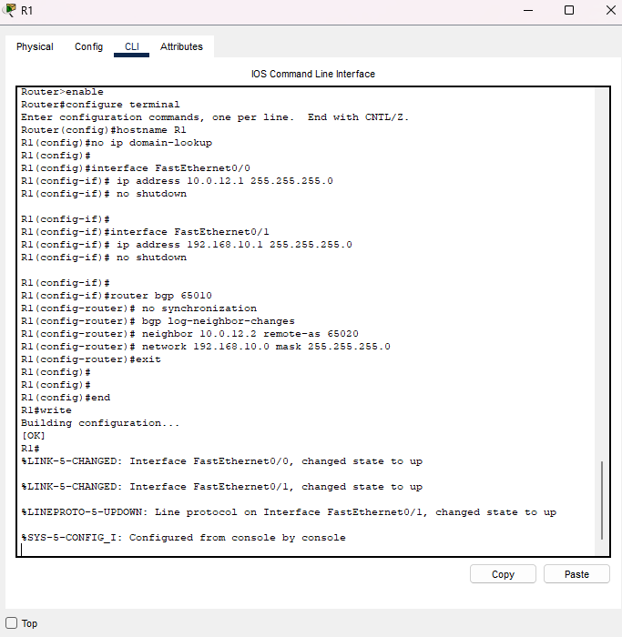
R2 (AS 65020)

enable
configure terminal
hostname R2
no ip domain-lookup # disables delays caused by mistyped commands

interface FastEthernet0/0
ip address 10.0.12.2 255.255.255.0
no shutdown

interface FastEthernet0/1
ip address 192.168.20.1 255.255.255.0
no shutdown

interface FastEthernet1/0
ip address 10.0.13.1 255.255.255.0
no shutdown

router bgp 65020
no synchronization
bgp log-neighbor-changes
neighbor 10.0.12.1 remote-as 65010
neighbor 10.0.13.2 remote-as 65100
network 192.168.20.0 mask 255.255.255.0
exit

end
write
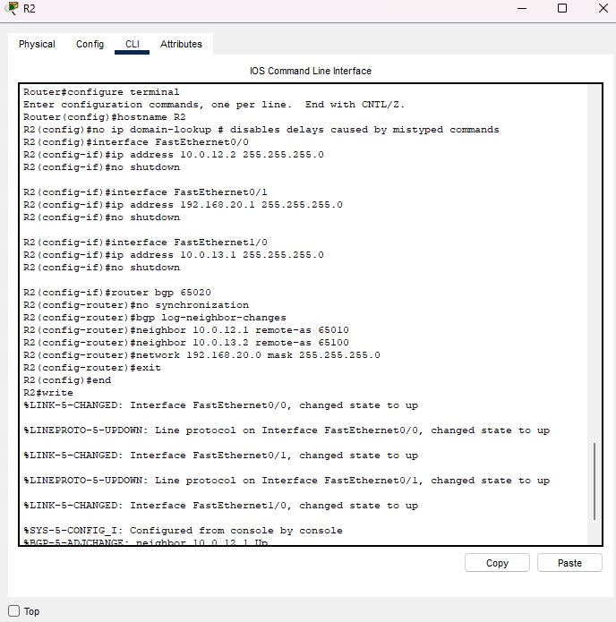
ATT (Attacker, AS 65100) — initial state (announce nothing)
enable
configure terminal
hostname ATT
no ip domain-lookup

interface FastEthernet0/0
ip address 10.0.13.2 255.255.255.0
no shutdown

router bgp 65100
no synchronization
bgp log-neighbor-changes
neighbor 10.0.13.1 remote-as 65020
exit

end
write
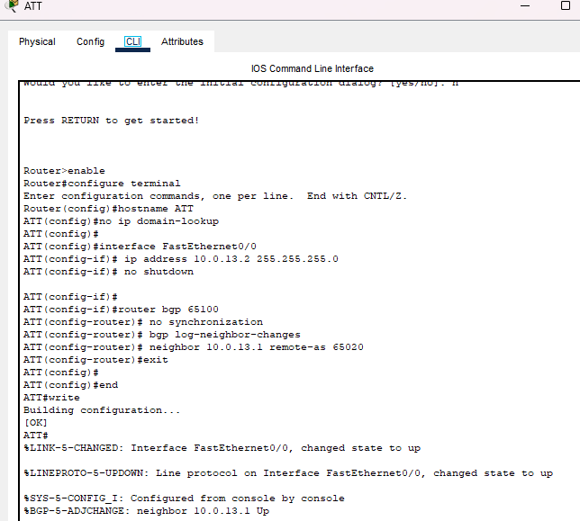
Note: no ip domain-lookup disables delays caused by mistyped commands.
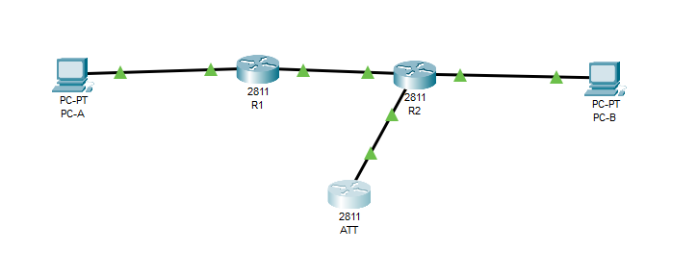

Checks before the attack

- On R1 and R2: show ip bgp summary — ensure neighbors are established (State = Established).

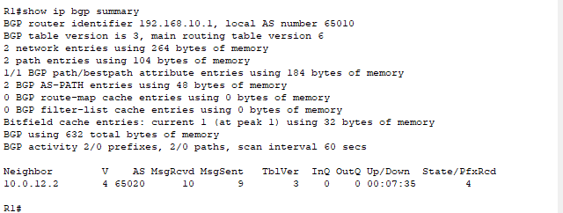
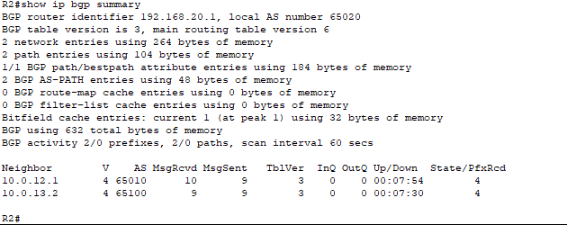
- On R2: show ip bgp — 192.168.20.0/24 should be advertised.
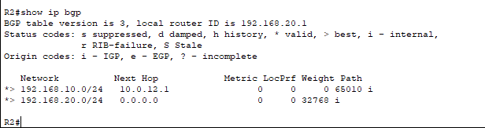
- On PC-A: ping 192.168.20.10 — should reply.
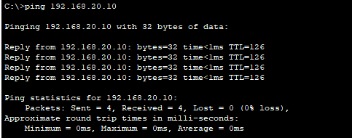
Take screenshots: show ip bgp (before hijack) and successful ping.

Simulating the hijack

On ATT, enter:

enable
configure terminal
router bgp 65100
network 192.168.20.0 mask 255.255.255.0
end
write
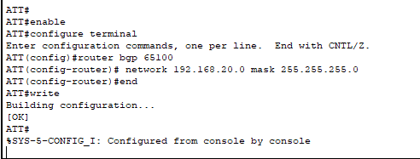
— now ATT announces the same prefix 192.168.20.0/24.

After that:
- On R1 and R2: show ip bgp — compare to previous output (you should see a path via AS65100 or a new entry).
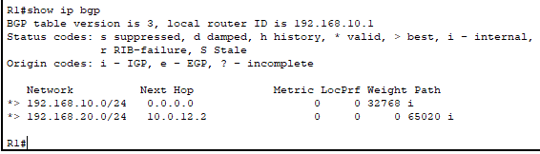
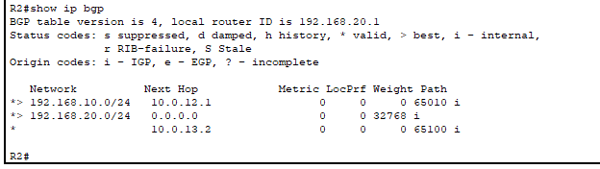
- On PC-A: tracert 192.168.20.10 (or Trace in PT) — the path may go through ATT.
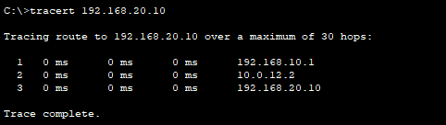
Take screenshots: show ip bgp (after hijack), traceroute/ping.

Protection — simple filter on R2
On R2, create a prefix-list and attach a route-map to the ATT neighbor to filter incoming announcements:

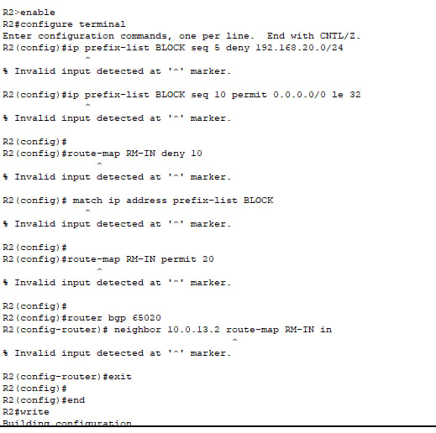

Topic 7: Wireless Network Security — Wi-Fi WPA2/WPA3 (Identification of Vulnerabilities)

This report summarizes the results of passive and targeted scanning of wireless networks, extracting RSN IEs from beacon frames, capturing EAPOL/PMKIDs, and analyzing risks. Below are detailed instructions, a network table, screenshot locations, and recommendations.

1. Objective

Objective: Monitor the wireless environment, collect data on five selected networks, obtain RSN IEs and (if available) capture 4-way EAPOL handshake and/or PMKIDs, analyze the security level, and prepare recommendations for improving security.

2. Hardware and Software

Adapter: USB TP-Link Archer T2U PLUS (Realtek RTL8821AU chip)

Kali Linux (in VirtualBox, adapter drivers are working)

airodump-ng, aircrack-ng, hcxdumptool, Wireshark, nmcli, iw, rfkill.

3. Brief Procedure

1. Check adapter visibility: lsusb (write down the line with VID:PID and name).

2. Install the driver if necessary (example for RTL8821AU: morrownr/8821au via DKMS).

3. Enable monitor mode: airmon-ng start <iface> or iw dev ... set type monitor.

4. Passively scan the air: airodump-ng --band abg -w capture wlan0.

5. Targeted capture (by BSSID and channel) to obtain EAPOL/PMKID: airodump-ng --bssid ... -c ... -w target.

6. Open the capture in Wireshark and take screenshots: Beacon → RSN Information; filter eapol.

7. Return the system to normal mode: airmon-ng stop wlan0mon, systemctl start NetworkManager, modprobe -r <driver> (optional).

4. Table of selected networks
No. | SSID | Security Type (WPA2, WPA3, Open) | Encryption (AES, TKIP) | Notes (e.g., WPS enabled, MFP missing)
1 | Jamal | WPA3 | CCMP | SAE
2 | Study | WPA2 | CCMP
3 | Office | WPA2 | CCMP
4 | Wifi-Guest | WPA2 | CCMP
5 | Lab342 | WPA2 | CCMP
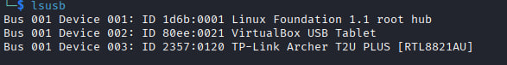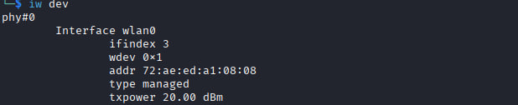
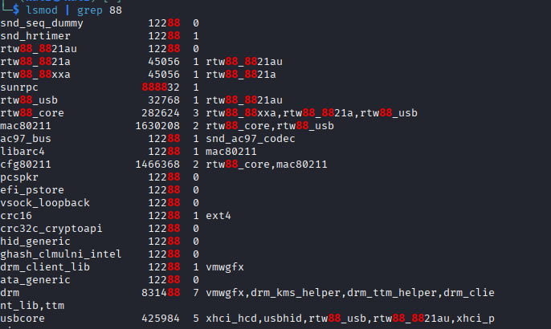

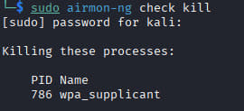
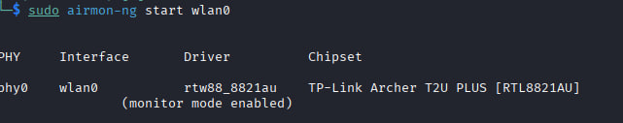
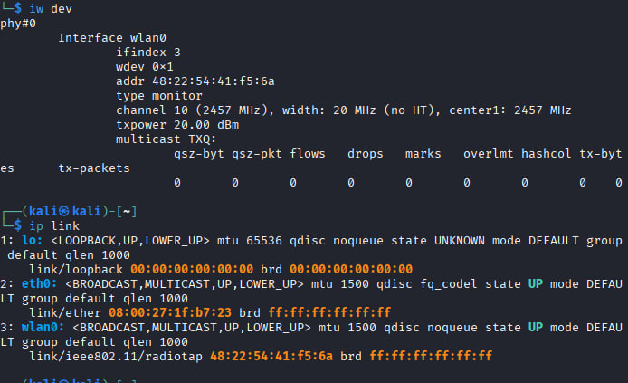

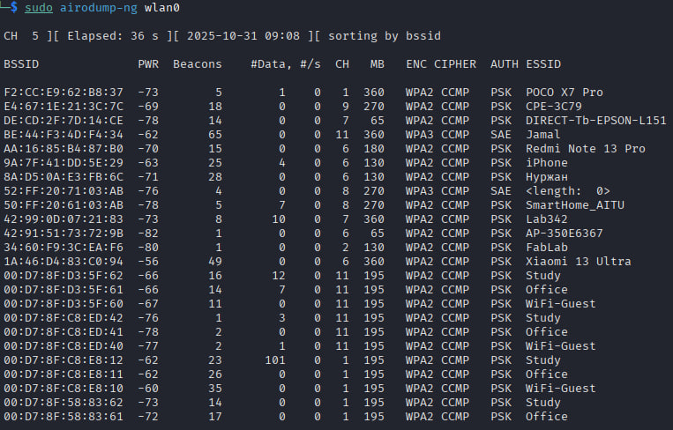
6. Vulnerability analysis (templates to fill out)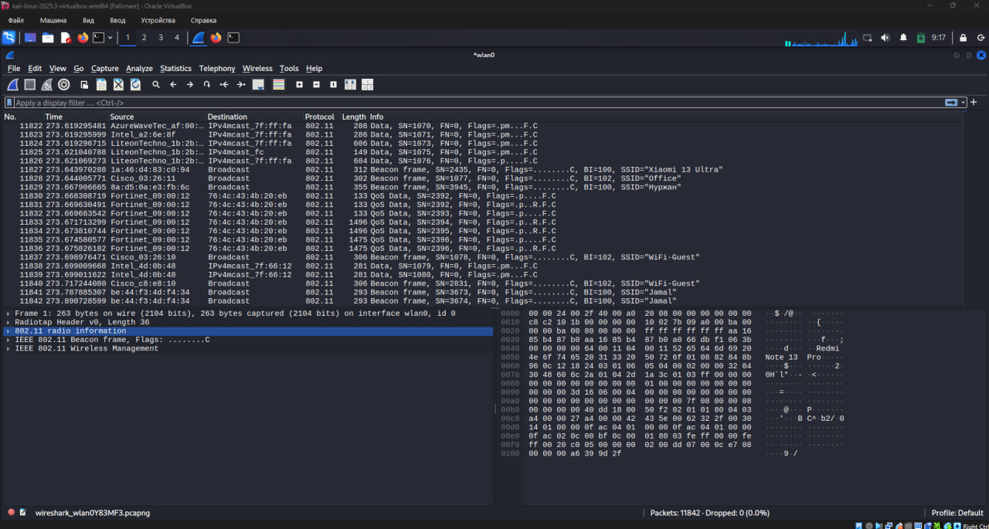
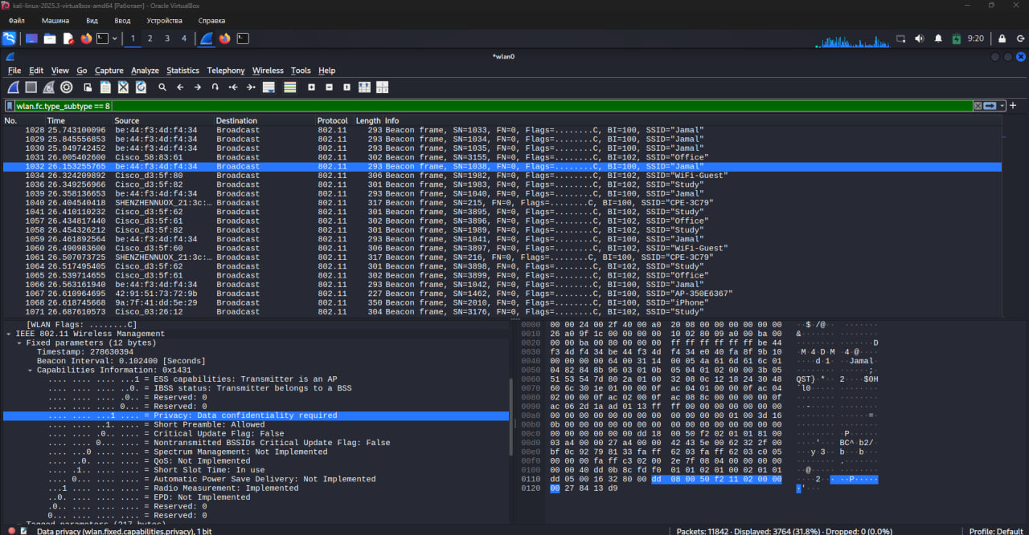
We need to determine:
Pairwise Cipher Suites — (CCMP/AES or TKIP);
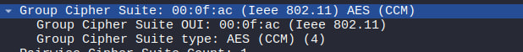
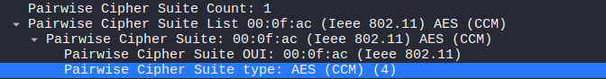
AKM Suite — (PSK / SAE / 802.1X);
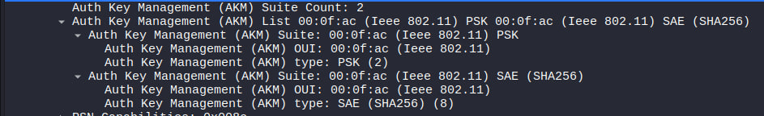
RSN Capabilities — (presence or absence of MFP);
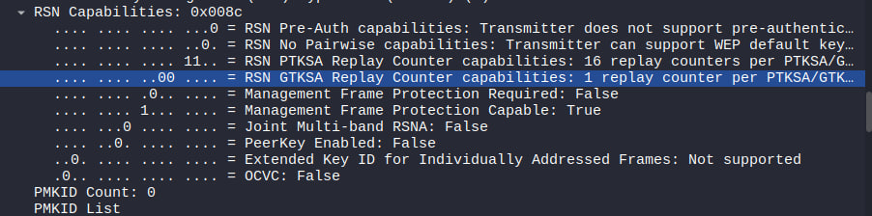
Next, we need to apply the eapol filter to detect a four-way handshake. The screenshot shows that no four-way handshake was detected.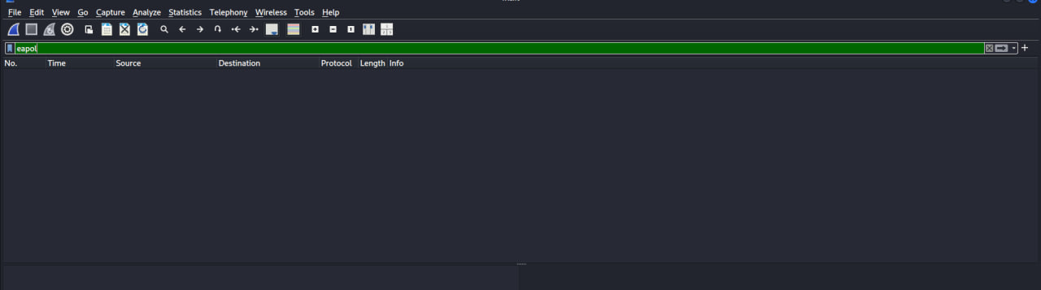
After completing the task, we need to reset all configurations: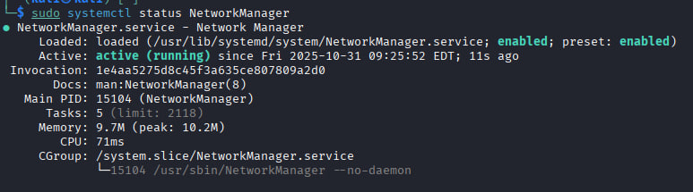
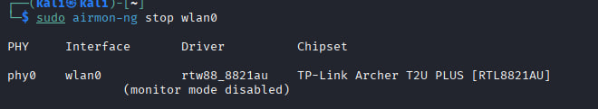
KRACK (Key Reinstallation Attack): Description: A vulnerability in the 4-way handshake allows reinstallation of keys and decryption of traffic. Mitigations: OS/firmware updates, use TLS/VPN.
PMKID attack: Description: PMKID capture allows offline brute-force of the PSK. Mitigations: Switch to WPA3/Enterprise, use strong passwords.
Dragonblood (WPA3): Description: SAE implementation issues; Mitigations: Firmware updates, patch checks.
7. Security Recommendations
• Switch to WPA3 (where possible) or WPA2-Enterprise (802.1X) for corporate networks.
• Disable WPS on access points.
• Enable Management Frame Protection (MFP) / Protected Management Frames.
• Use long and random passphrases (PSK) of at least 20 characters for home networks.
• Periodically update AP/router firmware and client OS.

Topic 8: Topic: VPN and Secure Tunnel Technologies (OpenVPN and WireGuard)
Objective
The objective of this report is to understand the fundamental principles of Virtual Private Networks (VPNs), to install and configure a secure tunnel using the modern WireGuard protocol, and to verify both the encryption and connectivity functionality of the VPN.
Background Theory
A Virtual Private Network (VPN) is a technology that establishes an encrypted “tunnel” between a user’s device and a remote server. This tunnel ensures that data transmitted between the two endpoints is secure and protected from interception or unauthorized access.
The most common VPN protocols include:
OpenVPN — a reliable protocol that typically requires manual configuration using certificates.
WireGuard — a modern VPN protocol that is fast, lightweight, and easy to configure.
WireGuard operates using public and private key pairs and features minimal configuration requirements, making it well-suited for educational and laboratory applications.
9

Setup

0. Environment
- Windows 11 OS
- Debian Linux 13 inside VirtualBox
- Internet connection from Beeline ISP
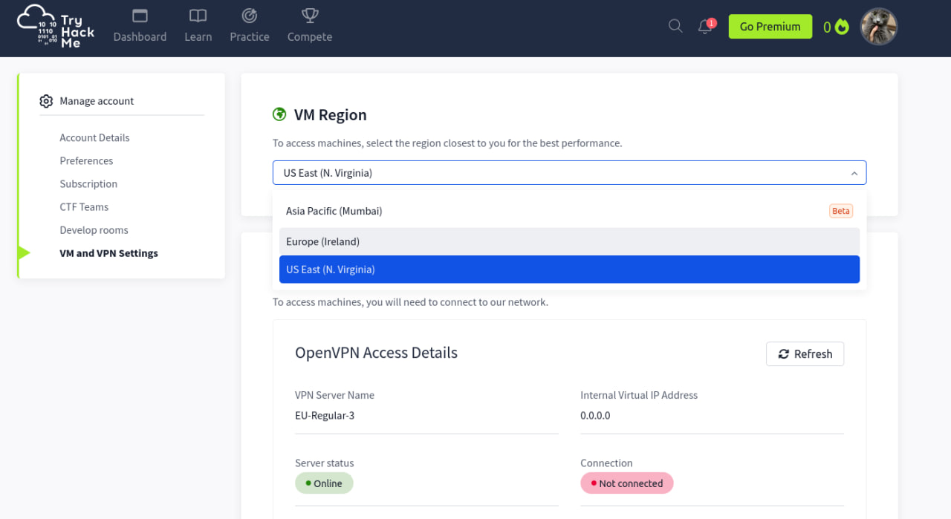
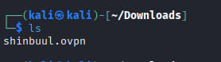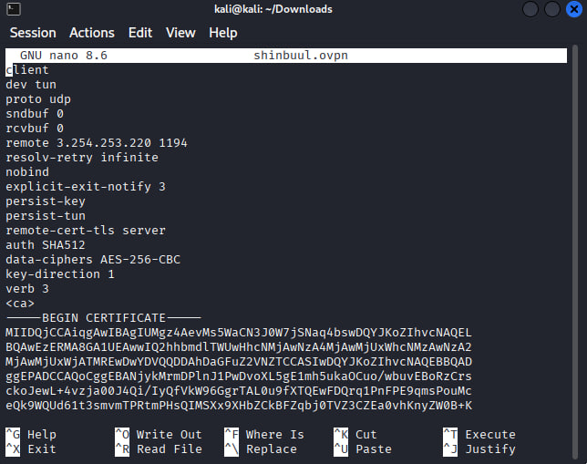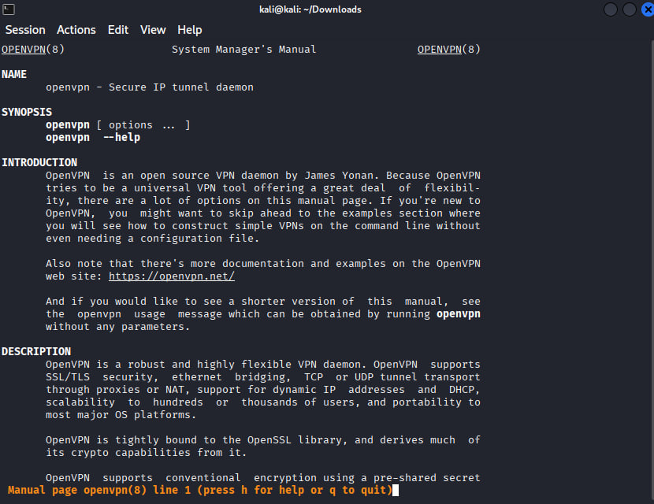
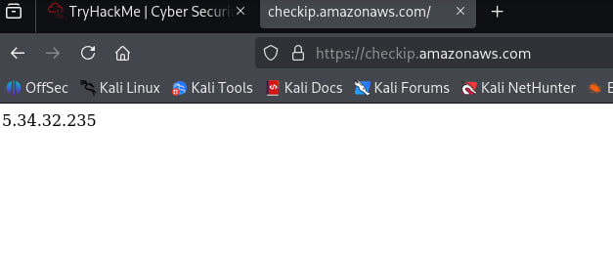
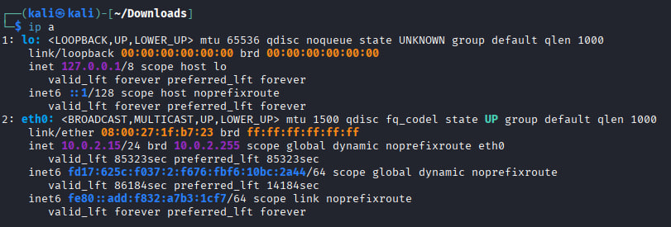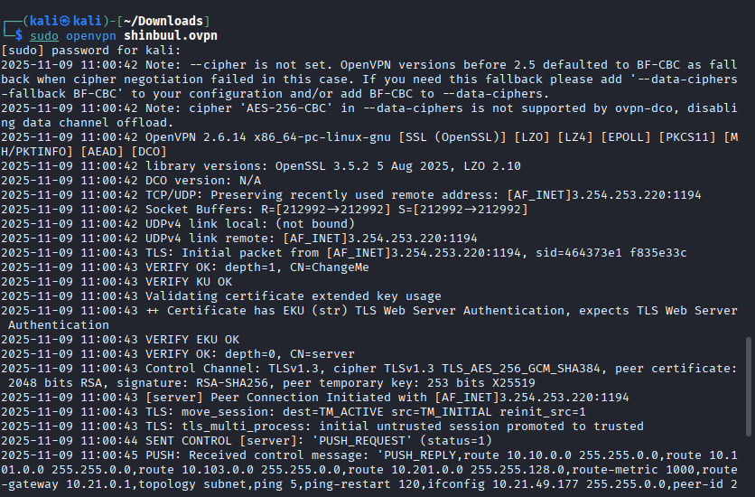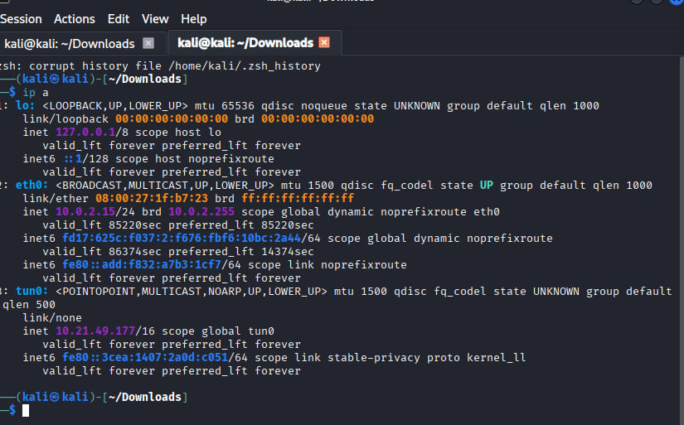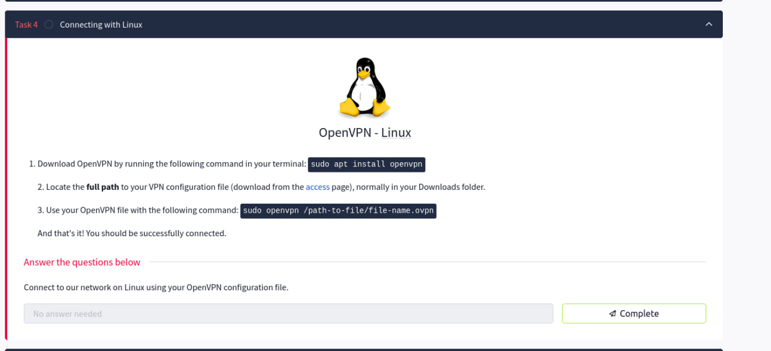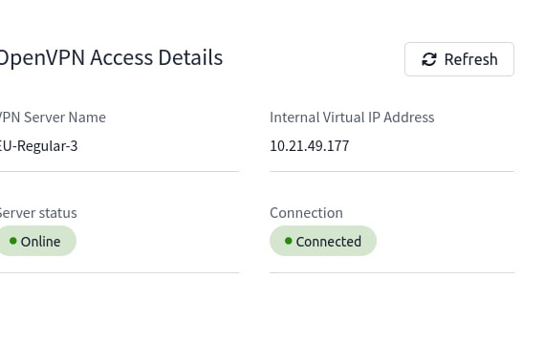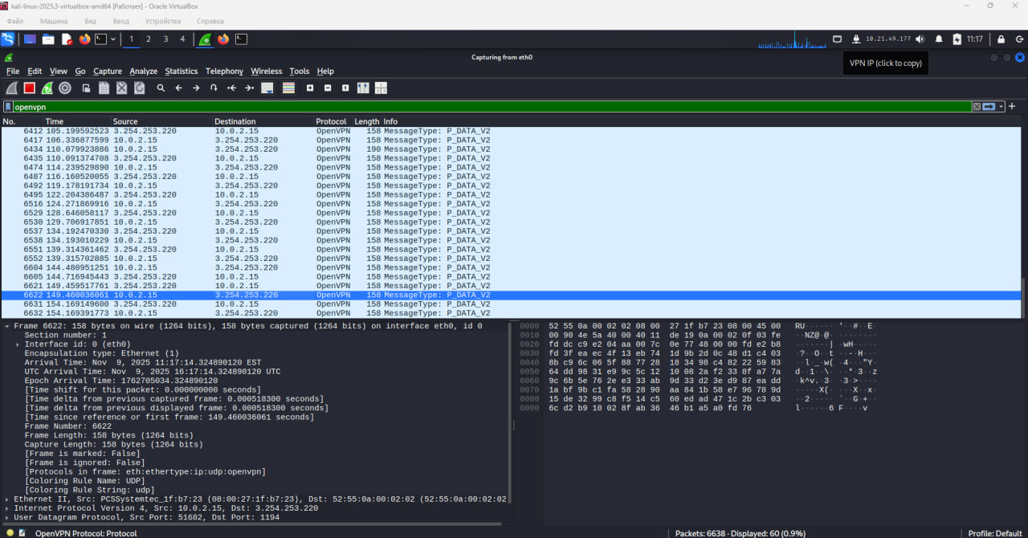

1. What is a VPN and what is it used for?
A VPN (Virtual Private Network) is a technology that creates an encrypted tunnel between a user’s device and a remote server. It is used to protect data from interception, ensure privacy, hide the real IP address, securely access remote networks, and bypass geographic restrictions.
2. How does OpenVPN differ from WireGuard?
OpenVPN is an older, highly configurable protocol that relies on certificates and complex configuration files, which can make setup slower and more cumbersome.
WireGuard is a newer protocol that uses modern cryptography, has a smaller codebase, is easier to configure, and generally provides faster performance with lower latency.
3. What does the AllowedIPs parameter mean in the configuration file?
The AllowedIPs parameter defines which IP addresses or networks should be routed through the VPN tunnel.
For example, 0.0.0.0/0 means that all traffic will go through the VPN, while specific subnets (e.g., 10.0.0.0/24) would limit the tunnel only to those networks.
4. How can you verify that the connection is encrypted?
You can verify encryption by capturing traffic on the WireGuard interface using tools like Wireshark. The packets will appear as UDP frames, but their contents will be unreadable (encrypted). This confirms that data is protected inside the tunnel.

Topic 9: Cloud and Container Security Exploration: Implementation of Security Policies in Docker and Kubernetes

1. Purpose of the Work

- To study modern approaches to securing containerized environments.
- To implement container security policies in Docker and Kubernetes.
- To perform vulnerability analysis of container images and assess the effectiveness of security mechanisms.
- To develop practical skills in applying security policies to protect applications in cloud infrastructures.

2. Theoretical Background

Modern applications are increasingly deployed in containers, which provide portability, scalability, and flexibility. However, containers share the same OS kernel, which introduces specific security risks.
Key directions for container security include:
- Privilege restriction (via capabilities, no-new-privileges, seccomp, AppArmor, SELinux);
- Image security (vulnerability scanning, minimizing base images);
- Process and file system isolation (using namespaces and cgroups);
- Kubernetes security policies — SecurityContext, Pod Security Standards (levels: Privileged, Baseline, Restricted).

Common container security tools:
docker scan, trivy, grype, falco, kube-bench.

3. Work Plan
Step 1. Environment Setup
Install Docker Desktop or Minikube (a local Kubernetes cluster).
sudo apt update
sudo apt install docker.io -y
sudo systemctl enable docker –now

~~~
curl -LO https://storage.googleapis.com/minikube/releases/latest/minikube-linux-amd64
sudo install minikube-linux-amd64 /usr/local/bin/minikube
Verify correct installation:

docker run hello-world
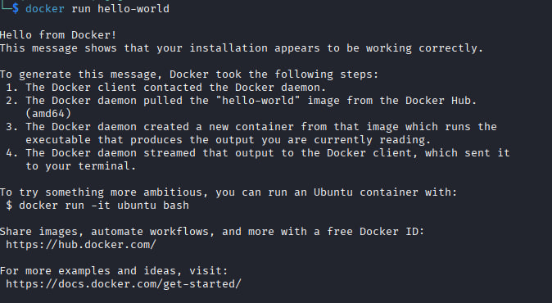
kubectl version
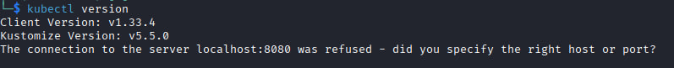
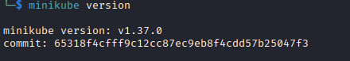
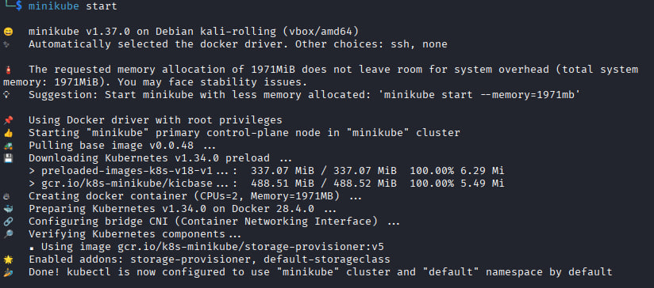
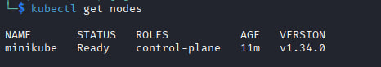

Step 2. Configuring a Secure Docker Container
Run a container with restricted privileges:
docker run -d --read-only --cap-drop ALL \
--security-opt no-new-privileges \
nginx
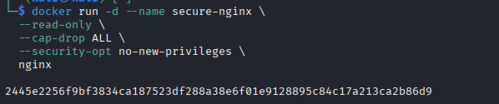
--read-only — makes the container's filesystem read-only → nothing can be modified or written to.
--cap-drop ALL — removes all additional Linux privileges → the container cannot perform dangerous system actions.
--security-opt no-new-privileges — prevents privilege escalation, even through vulnerabilities or setuid → it is impossible to become a superuser.

Check remaining capabilities:

docker exec <container_id> capsh –print
The container stopped immediately after starting. This is normal for nginx if we specified --read-only, but it tries to write logs and can't.

Step 3. Container Vulnerability Analysis

- Install and use a vulnerability scanning tool:
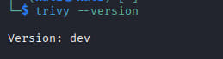

trivy image nginx
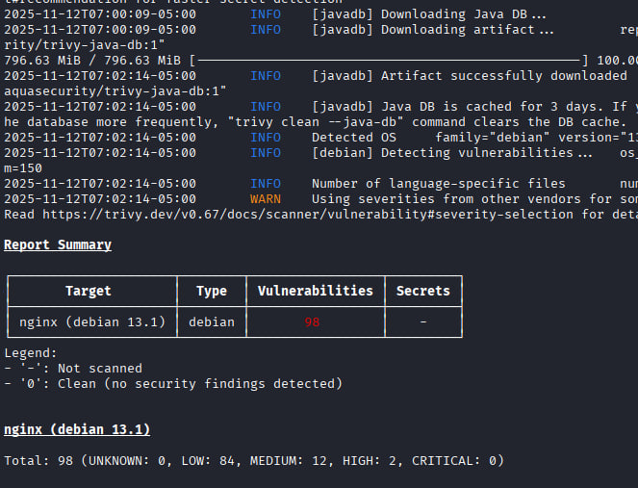

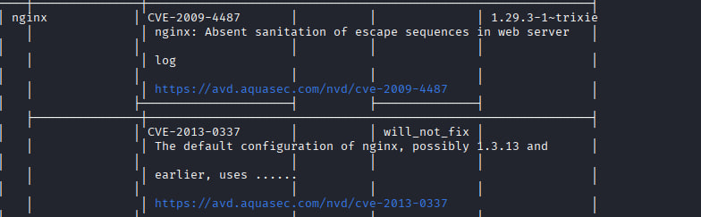

- Record identified vulnerabilities in a table (CVE ID, severity, package, version).
- Compare results for nginx and nginx:alpine images.
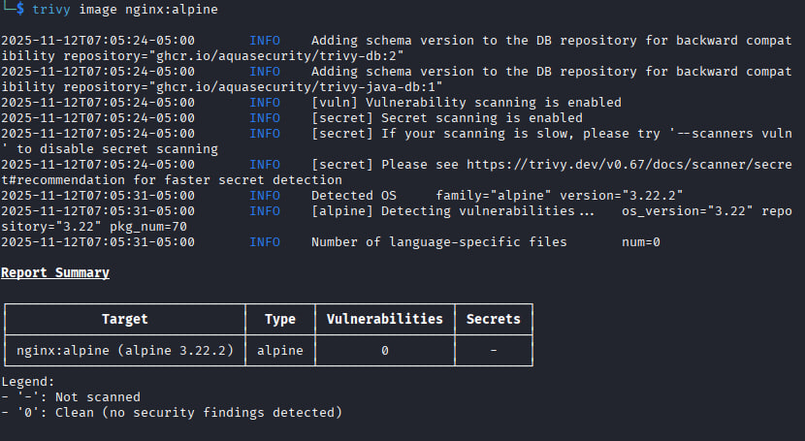

Step 4. Implementing Security Policies in Kubernetes
Create two Pod manifests:
insecure-pod.yaml — without security restrictions;
secure-pod.yaml — with a configured securityContext:
Deploy the Pod and check its status:

kubectl apply -f secure -pod.yaml
kubectl describe pod secure-pod
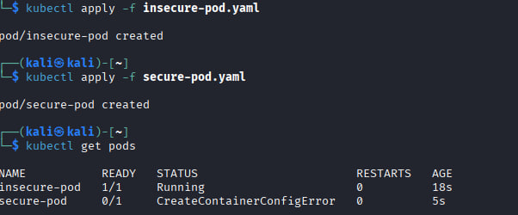
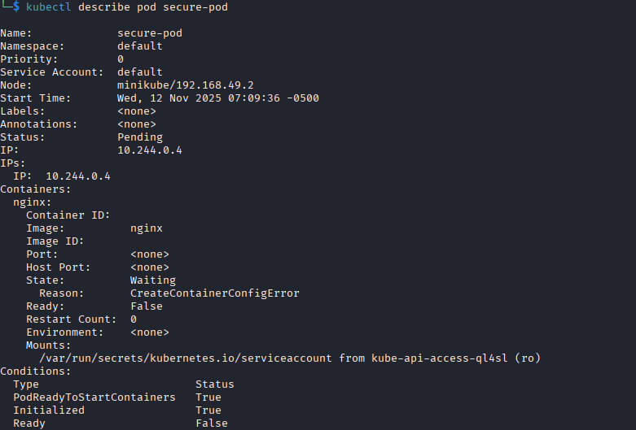
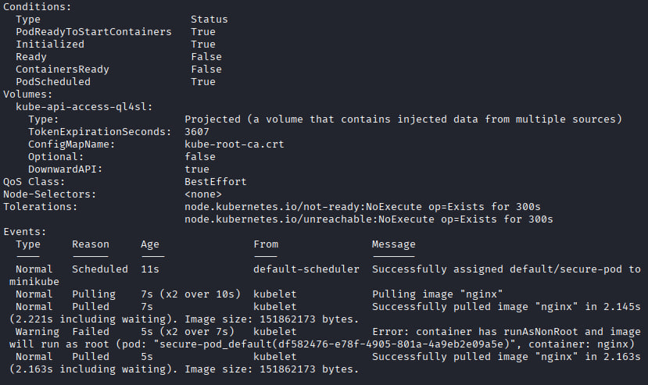

Step 5. Enforcing Pod Security Standards

Apply the restricted security level to the namespace:
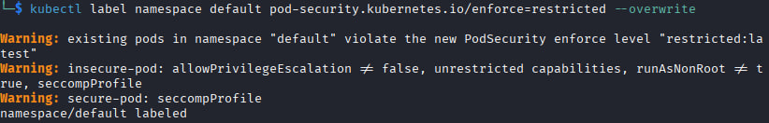
Attempt to launch insecure-pod — confirm that it is blocked by Kubernetes.
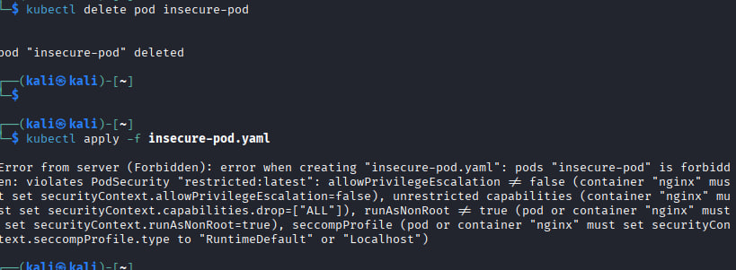

4. Control Questions
1. Which Linux mechanisms ensure container isolation?
Containers rely on several Linux kernel features to isolate processes, resources, and networks:
Namespaces: Provide isolation for various aspects of a container. Examples:
PID namespace – isolates process IDs.
NET namespace – isolates network interfaces.
MNT namespace – isolates filesystem mount points.
IPC namespace – isolates inter-process communication.
UTS namespace – isolates hostnames and domain names.
USER namespace – maps container users to host users.
Control Groups (cgroups): Limit and account for resource usage (CPU, memory, I/O) per container.
Seccomp (Secure Computing): Filters system calls a container can make, reducing the attack surface.
Capabilities: Fine-grained permissions instead of full root privileges.
SELinux / AppArmor / TOMOYO: Mandatory access control (MAC) frameworks to restrict container actions beyond traditional Unix permissions.

2. What does the Docker option --no-new-privileges do?
The --no-new-privileges flag prevents a process in a container (or its children) from gaining additional privileges through mechanisms like setuid or setgid.
Even if a binary inside the container is setuid root, it will not escalate privileges.
Helps prevent privilege escalation attacks.
Syntax example:
docker run --no-new-privileges mycontainer

3. What are the main Pod Security levels in Kubernetes?
Kubernetes defines Pod Security Standards (PSS) as three levels for restricting pod capabilities:
Privileged – Minimal restrictions, pods can do almost anything (least secure).
Baseline – Moderate security; prevents known privilege escalations but allows common workloads.
Restricted – Strong security; prevents privilege escalation, host filesystem access, and host networking (most secure).
These can be enforced via Pod Security Admission (PSA) in namespaces.

4. How can container images be checked for vulnerabilities?
Several methods exist:
Static scanning: Analyze the image without running it. Tools:
Trivy, Clair, Anchore, Snyk.
Detect outdated packages, known CVEs, misconfigurations.
CI/CD integration: Scan images before deployment to prevent vulnerable containers from reaching production.
Runtime scanning: Monitor containers during execution for suspicious behavior.
Example with Trivy:
trivy image nginx:latest

5. Why do minimal base images improve security?
Fewer packages → smaller attack surface: Less software means fewer vulnerabilities to exploit.
Reduced size → faster scanning and deployment.
Simpler maintenance: Fewer updates and dependencies to manage.
Examples: alpine, distroless, busybox are popular minimal base images.

6. How do security policies affect performance and usability of containerized applications?
Restrictive policies may break legacy applications or require code changes.
Limiting privileges (capabilities, network access) can prevent misconfigured apps from running properly.

Topic 10: Development of an Organizational Security Policy: ISO 27001, NIST CSF, GDPR Compliance and Risk Management Justification
Task 1. Analysis of Standards and Frameworks
1.1 Overview of ISO/IEC 27001, NIST CSF, GDPR
Standard | Focus | Key Requirements
ISO/IEC 27001 | Information Security Management System (ISMS) | Risk management, security controls (Annex A), asset management, access control, auditing, incident response
NIST CSF | Cybersecurity posture improvement | Identify–Protect–Detect–Respond–Recover, risk assessment, continuous monitoring
GDPR | Personal data protection in the EU | Lawfulness, transparency, data minimization, storage limitation, confidentiality, integrity, accountability

1.2 Overlapping Areas
All three frameworks overlap in:
- Risk management
- Access control & authentication
- Incident response
- Logging & monitoring
- Data protection & encryption
1.3 Comparison Table
Area | ISO 27001 | NIST CSF | GDPR
Risk Management | Required (Clauses 6, A.5) | Core function (Identify) | Implicit through DPIA
Access Control | Annex A.9 | Protect (PR.AC) | Data minimization & confidentiality
Incident Response | Annex A.16 | Respond (RS) | Breach notification (72 hours)
Data Protection | Annex A.8, A.10 | PR.DS (Data Security) | Articles 5, 25, 32
Monitoring | Annex A.12 | Detect (DE) | Accountability
Encryption | Annex A.10 | PR.DS-1 | Article 32: security of processing

Task 2. Organization / System Selection
Chosen Organization
Microsoft Azure Cloud Infrastructure, focusing on secure processing of encrypted data using Microsoft SEAL Fully Homomorphic Encryption (FHE) library.
Mission: To provide secure, scalable cloud services enabling computation over encrypted data without exposing plaintexts.
Main Information Assets;
- Encrypted customer datasets (financial, medical, operational)
- FHE keys (public, secret, relinearization, Galois keys)
- Azure infrastructure logs
- Virtual machines and compute clusters
- SEAL library components
Types of Processed Data
- Personal data (GDPR-relevant)
- Confidential business data
- Cryptographic keys
- Operational and telemetry data
Threats & Vulnerabilities:
- Phishing and credential theft
- Side-channel attacks on HE implementations
- Supply-chain attacks
- Unauthorized access to Azure resources
- Ransomware targeting customer endpoints
- Misconfiguration of cloud access policies

Task 3. Risk Identification and Assessment
Five Major Risks:
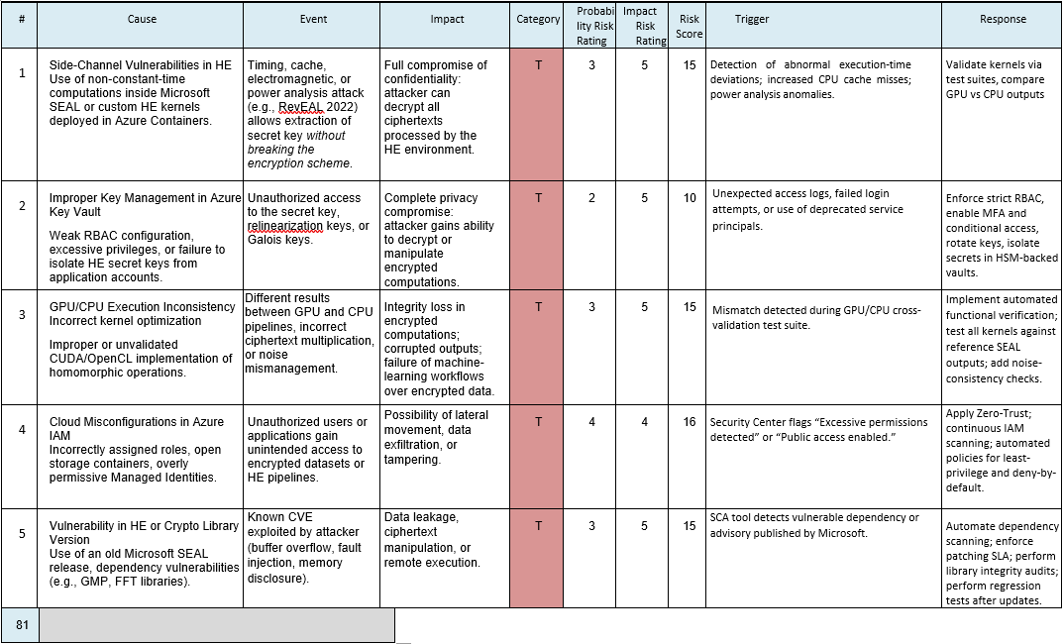
Risk Matrix:
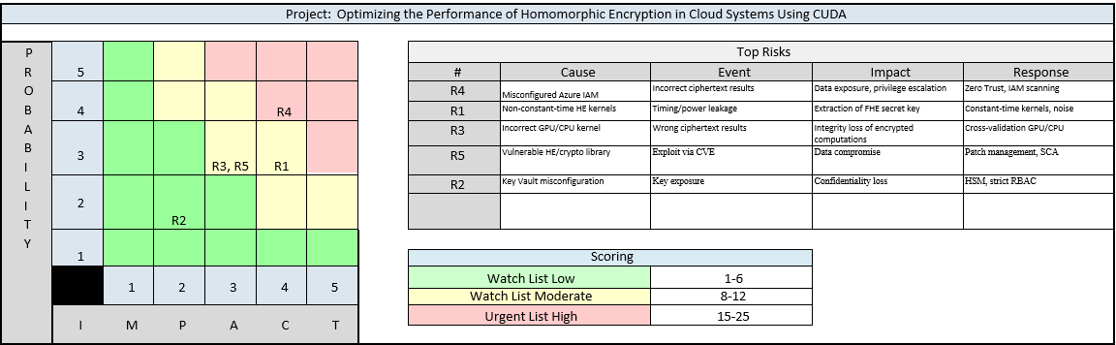
Task 4. Organizational Security Policy (Microsoft Azure + SEAL)
4.1 Purpose and Scope
This policy defines security requirements for handling encrypted data, cryptographic keys, cloud infrastructure, and FHE computations using Microsoft SEAL within Azure.
4.2 Roles and Responsibilities
- CISO: Oversees ISMS, approves controls.
- Security Engineers: Configure IAM, implement constant-time kernels, perform code reviews.
- Developers: Follow secure coding guidelines, avoid branch-dependent operations on secret data.
- Incident Response Team: Handles security incidents and breach notifications.
- End-Users / Customers: Maintain secure endpoints and MFA.

4.3 Access Control Policy
- Azure AD with mandatory MFA.
- Least privilege access (RBAC).
- Key vaults protected using HSM.
- No shared accounts.
- Logging of every access to FHE keys.

4.4 Data Classification & Protection
Classification Levels:
- Public
- Internal
- Confidential
- Cryptographic Secrets (highest level)
Protection Measures:
- Encryption at rest and in transit (TLS 1.3).
- For homomorphic encryption: keys separated per project & stored in secure enclaves.
- FHE implementations must use constant-time algorithms to avoid timing leakage.
Justification:
Side-channel leakage can expose SEAL private keys even if the ciphertext is secure.
Research example: RevEAL 2022 power analysis attack on Microsoft SEAL.
4.5 Incident Response Procedures
- 24/7 SOC monitoring Azure logs.
- Automated detection of anomalous access patterns.
- Response phases: Detection → Containment → Eradication → Recovery → Post-analysis.
- GDPR requires breach notification to authorities within 72 hours.

4.6 Business Continuity & Backup
- Geo-redundant backup of encrypted data.
- Regular disaster recovery tests.
- FHE keys backed up in encrypted HSM-protected storage.

4.7 Compliance & Auditing
- Annual ISO 27001 audit.
- Continuous IAM audit policies.
- GDPR: maintain processing records and DPIA for FHE computations.
- Code audits to ensure constant-time implementations.

Task 5. Compliance Mapping & Justification
5.1 Mapping Table
Policy Control | ISO 27001 | NIST CSF | GDPR | Notes
MFA + RBAC Access Control | A.9 | PR.AC | Art. 5, 32 | Prevents credential theft
Key Vault + HSM | A.10 | PR.DS-1 | Art. 32 | Protects encryption keys
Constant-time FHE kernels | A.14 (secure coding) | PR.IP-3 | Art. 25 (privacy by design) | Prevents side-channel leaks
Incident Response | A.16 | RS, DE | Art. 33 | Supports breach detection/notification
Backup & BCP | A.17 | Recover | — | Ensures service continuity
Data Classification | A.8 | Identify | Art. 5 | Minimizes unnecessary data exposure

Task 6. Executive Summary & Recommendations
6.1 Summary
- Main risks: phishing, side-channel vulnerabilities, misconfigurations.
- Controls implemented: MFA, RBAC, HSM key storage, encrypted backups, incident response program, constant-time mitigation.
- Compliance achieved: ISO 27001 (Annex A), NIST CSF, GDPR Articles 5/25/32.
6.2 Recommendations
- Expand constant-time review to all cryptographic components.
- Introduce periodic red-team testing targeting SEAL and Azure IAM.
- Implement Zero Trust architecture.
- Add automated scanning for misconfigurations.
6.3 Limitations & Next Steps
- Side-channel protections require hardware/firmware cooperation.
- GDPR compliance depends on customers’ endpoint security.
- Next: internal audits, employee anti-phishing training, regular DPIA updates.

